Noughts & Crosses

In this project you will create a noughts and crosses game in Scratch that is able to learn from how you play.

You won’t give it instructions for how to play, or tell it what the objective or rules of the game are.

Instead, you’ll show it examples of you playing the game. When it’s seen enough examples to start trying to play for itself, you’ll tell it when it beats you.

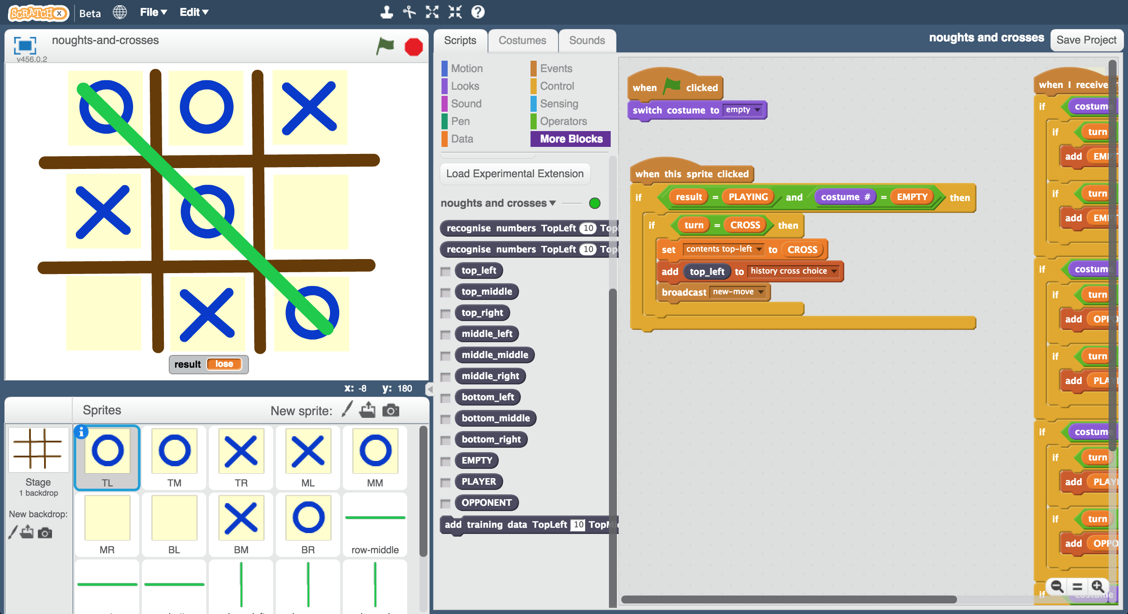

This project worksheet is licensed under a Creative Commons Attribution Non-Commercial Share-Alike License

http://creativecommons.org/licenses/by-nc-sa/4.0/

1. Go to <https://machinelearningforkids.co.uk/scratchx> in a browser.
2. Open the Noughts and Crosses project template   
   *Click* ***Project templates*** *->* ***Noughts and Crosses***  
   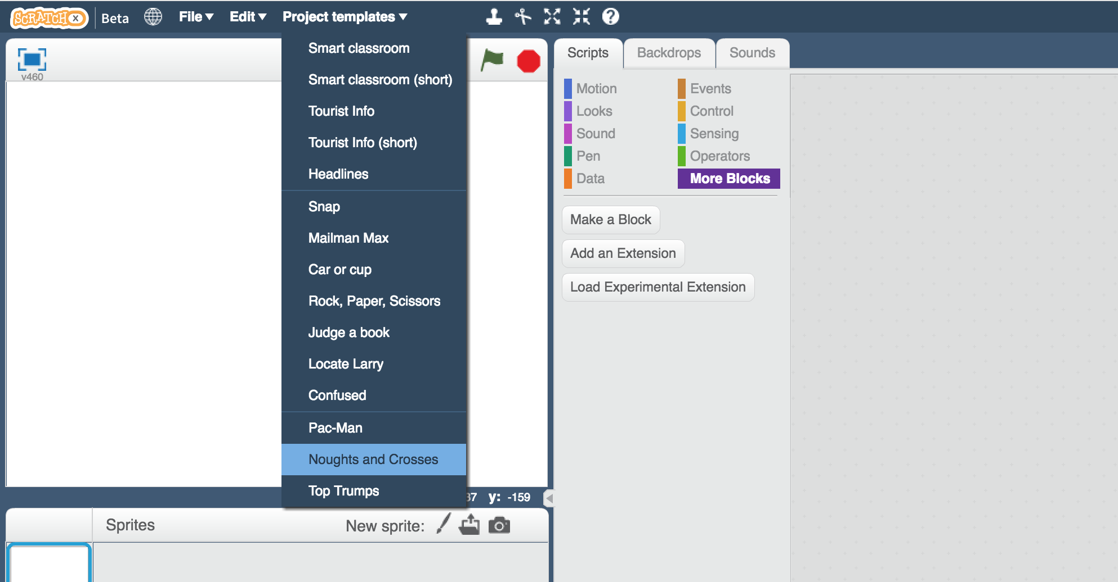
3. Click the **full-screen** button, and then click the Green Flag  
   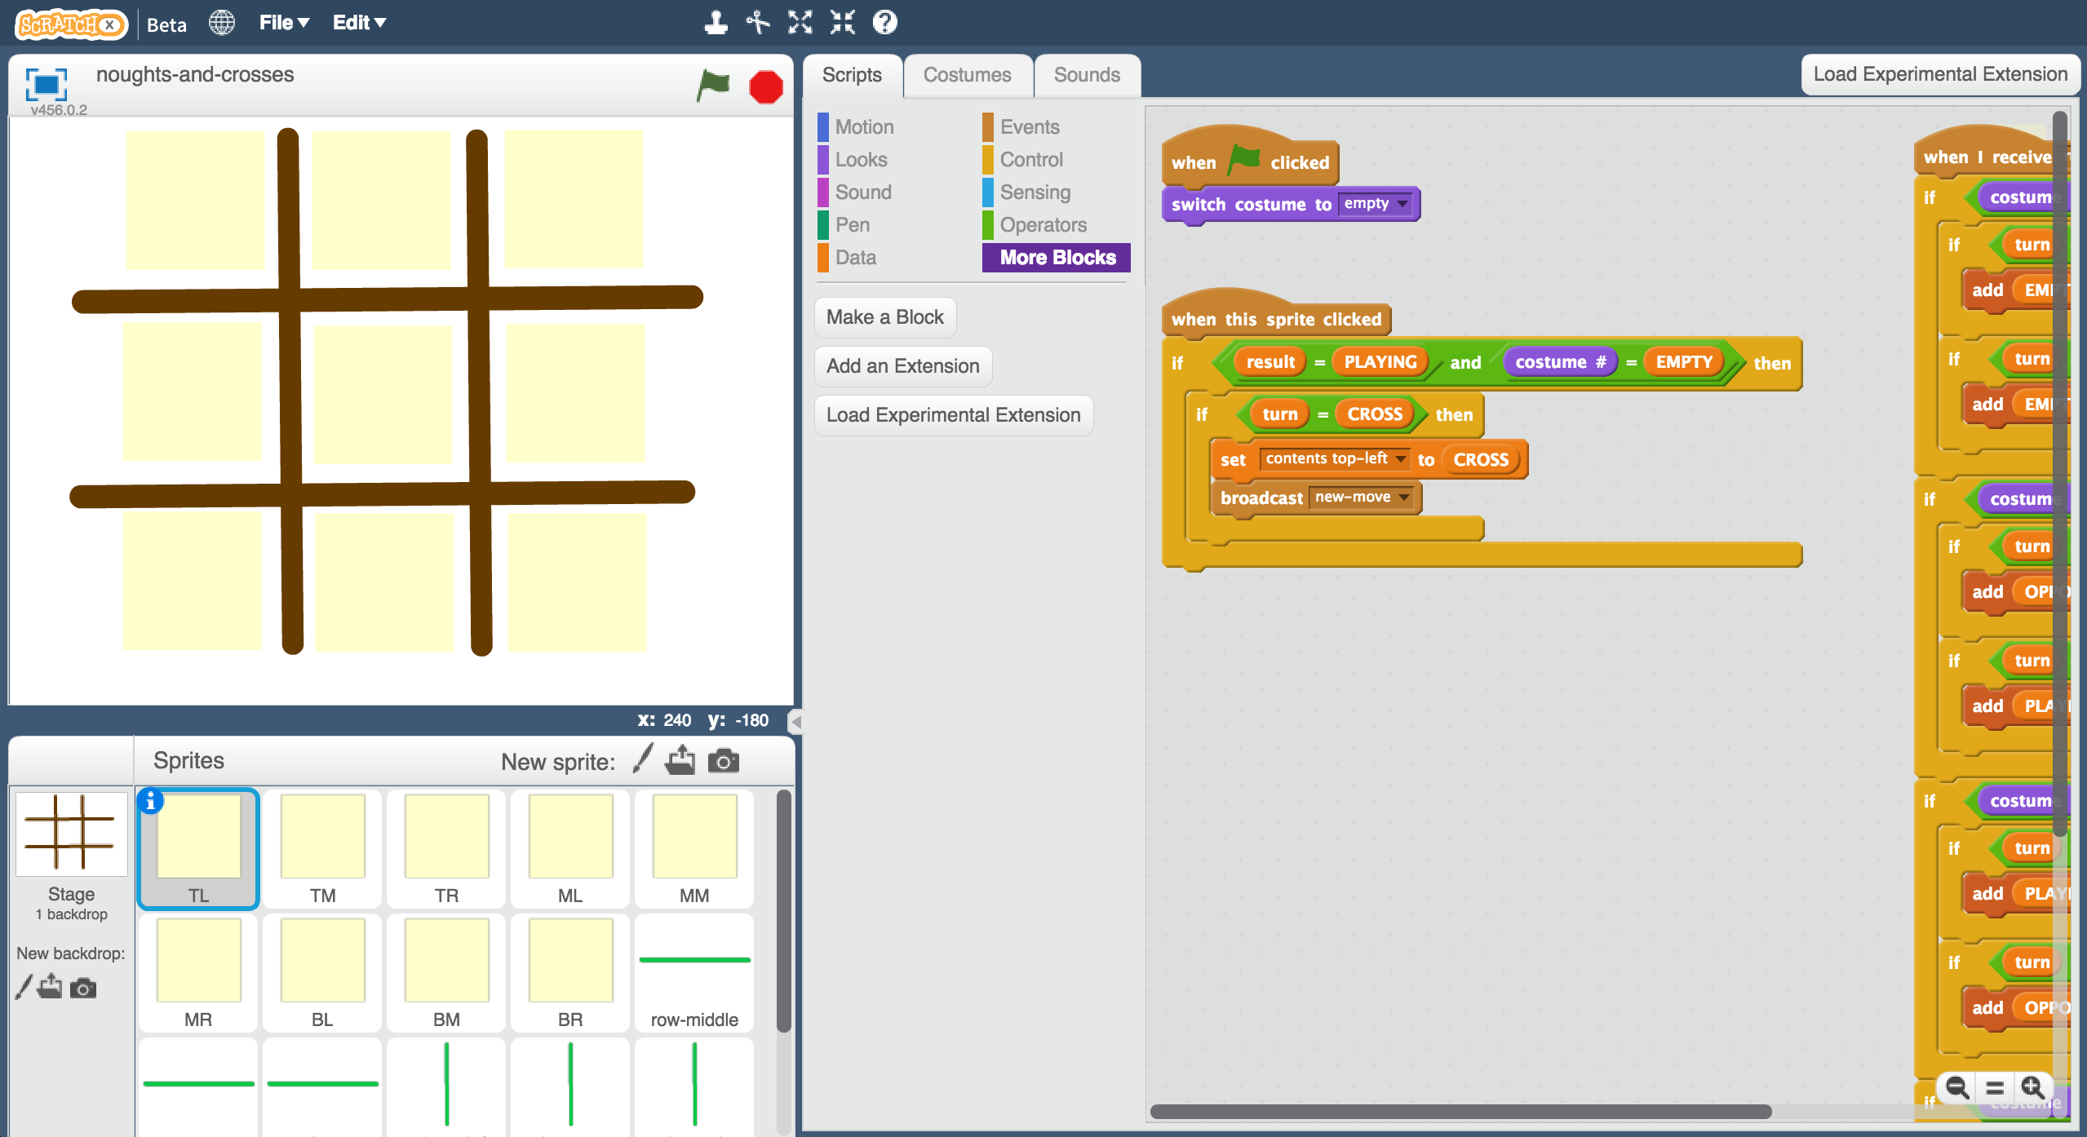
4. Play a few games of noughts and crosses  
   *You are CROSS (X), the computer is playing as NOUGHTS (O).*   
   *Click the green flag to start a new game, then click on the game board.*
5. Can you see how the computer is choosing where to put its moves?   
   *When you’ve worked it out, look at the* ***Computer move*** *block in the* ***Stage***  *Were you right?*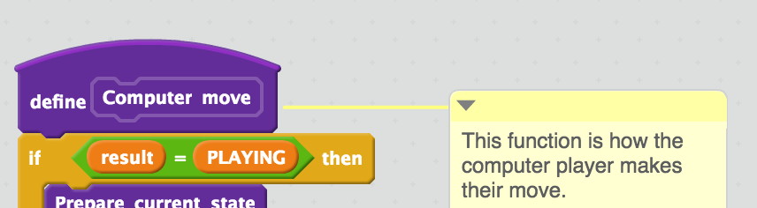

Representing noughts and crosses in Scratch

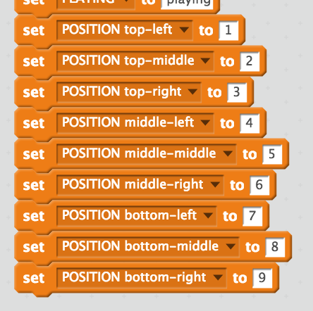

The positions of spaces on the noughts and crosses board are numbered from 1 to 9.

Data constants are used to make it easier to refer to them in scripts.

3

2

1

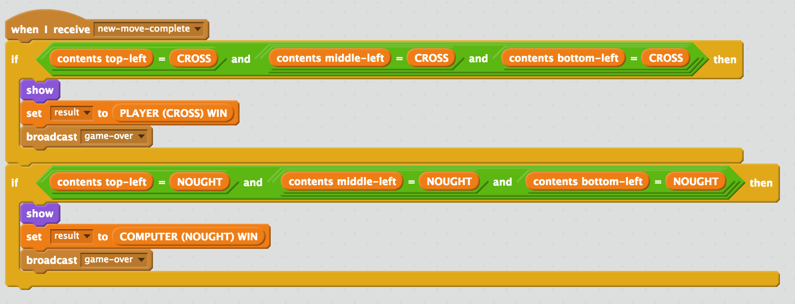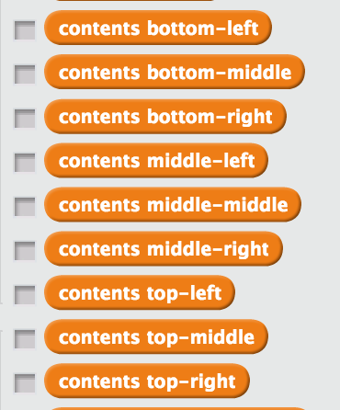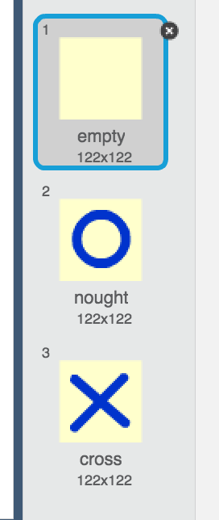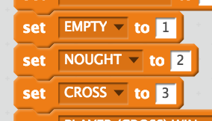

Variables are used to store the current state of the game.

For example, at this point:

contents top-left = 2

contents middle-middle = 3

contents bottom-right = 1

Each of the green row and column sprites check to see if someone has won.

This happens after every move.

X

O

Empty = 1

O = 2

X = 3

An empty space is shown in costume 1.

A nought is shown in costume 2.

A cross is shown in costume 3.

Data constants are used to make it easier to refer to these in scripts.

9

8

7

6

5

4

**What are you going to do?**

You’re going to train a computer to play noughts and crosses. You’ll do this by showing it examples of how you play the game.

Imagine the board looks like this and it’s O’s turn.

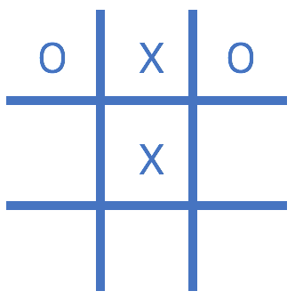

Imagine you decide to put your O in

the bottom middle space.

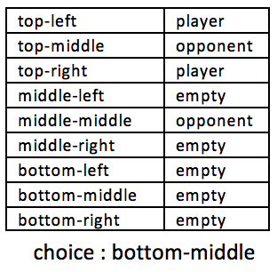

Imagine the board looks like this and it’s X’s turn.

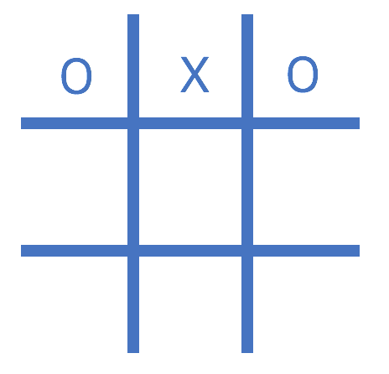

Imagine you decide to put your X in

the centre space.

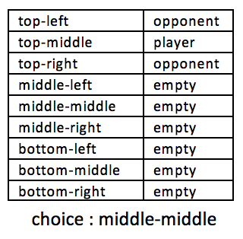

Using “opponent” and “player” instead of “nought” and “cross” means the computer can learn from both nought and cross moves.

You’ll only use examples of moves from the player that wins the game.

If you (X) win, use your moves as examples to train the computer.

If the computer (O) wins, use the computer’s moves to train with.

These **examples of moves that lead to winning** will teach the computer how to play to win!

1. Close the Scratch window.
2. Go to <https://machinelearningforkids.co.uk/> in a web browser
3. Click on “**Get started**”
4. Click on “**Log In**” and type in your username and password  
   *If you don’t have a username, ask your teacher or group leader to create one for you.  
   If you can’t remember your username or password, ask your teacher or group leader to reset it for you.*

1. Click on “**Projects**” on the top menu bar

1. Click on the **“+ Add a new project**” button.

1. Name your project “noughts and crosses” and set it to learn how to recognise “**numbers**”  
   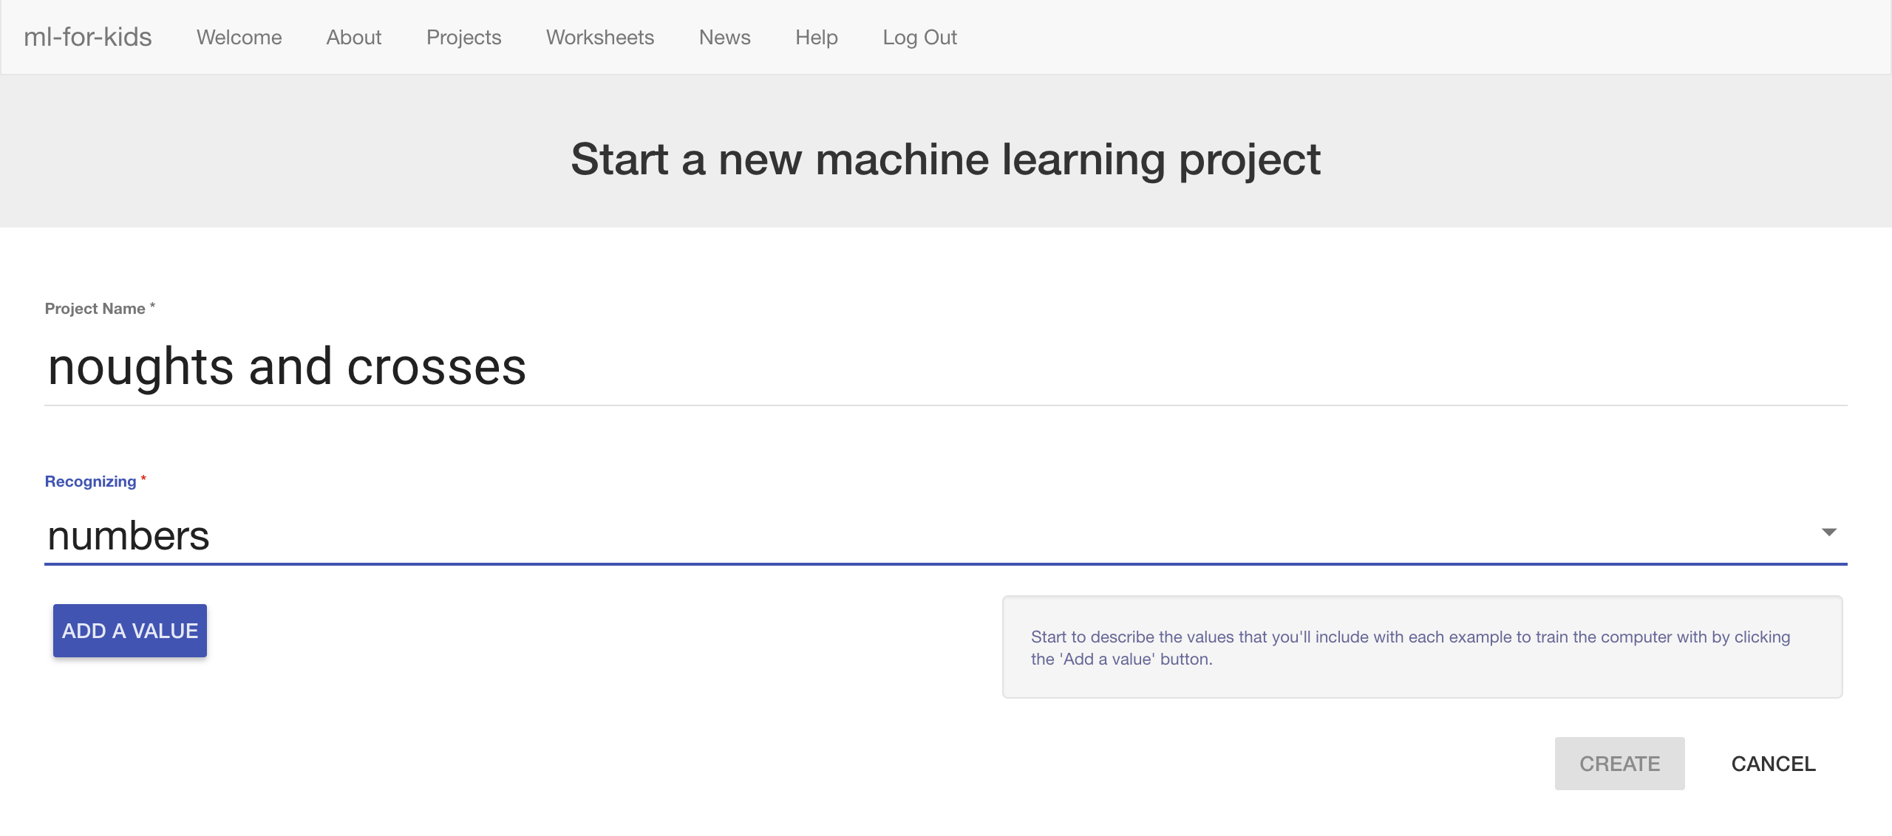
2. Click “**Add a value**” and name a value “TopLeft” and make it “multiple choice”.  
   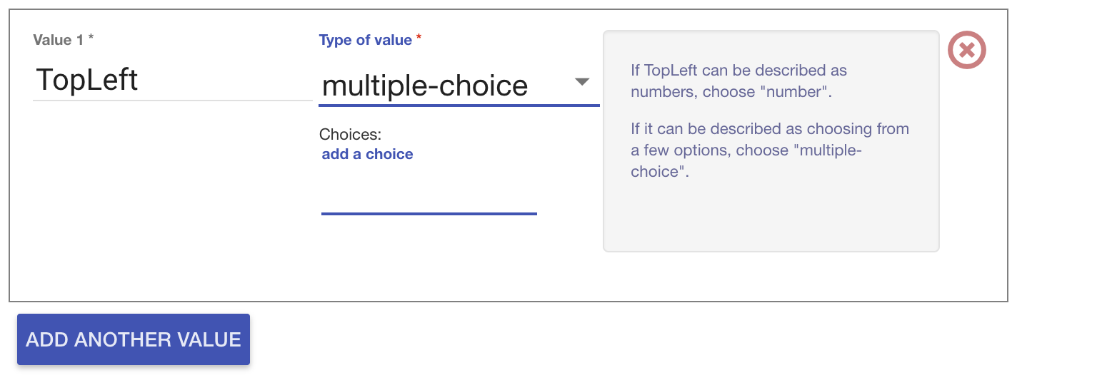
3. Type “EMPTY” into the “**add a choice**” box and press Enter  
   Type “PLAYER” into the “**add a choice**” box and press Enter  
   Type “OPPONENT” into the “**add a choice**” box and press Enter  
   *These are the possible contents for the top-left box in the noughts and crosses board. It can be empty, or it can have the player’s own shape (e.g. cross) in it, or it can have the opponent’s shape in it (e.g. nought).*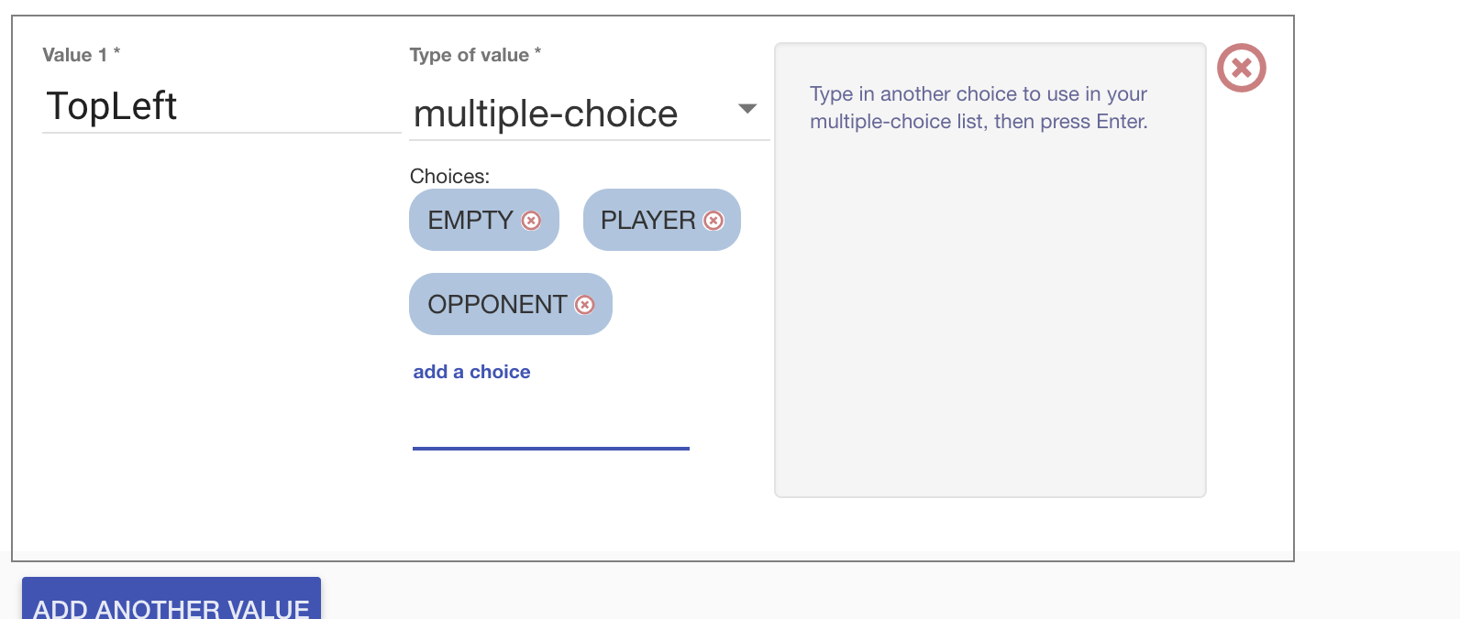
4. Click “Add another value” again and repeat to add values for the other eight positions on the board  
   *Each example is the state of the board before a move that led to a win. TopMiddle, TopRight, MiddleLeft, MiddleMiddle, MiddleRight, BottomLeft, BottomMiddle, BottomRight  
     
     
   It’s very important that you spell “EMPTY”, “PLAYER” and “OPPONENT” in the same way for all nine positions.*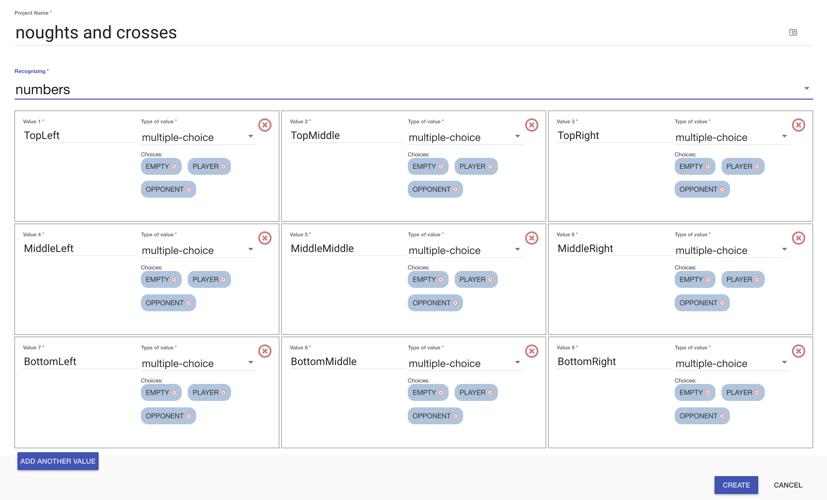
5. Click **Create**. You should see “**noughts and crosses**” show up in the list of your projects. Click on it.  
   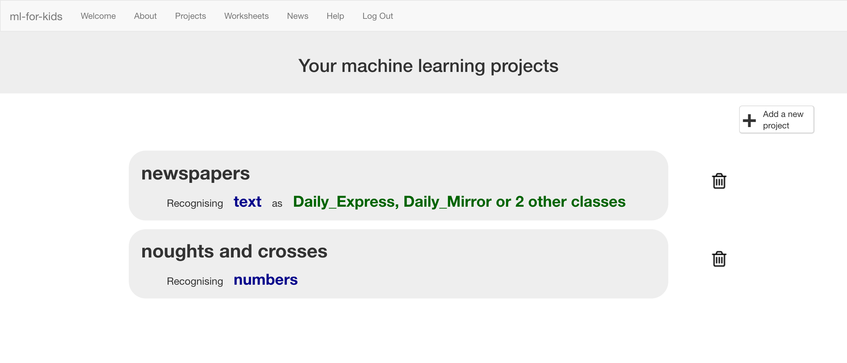
6. Click the “**Train**” button  
   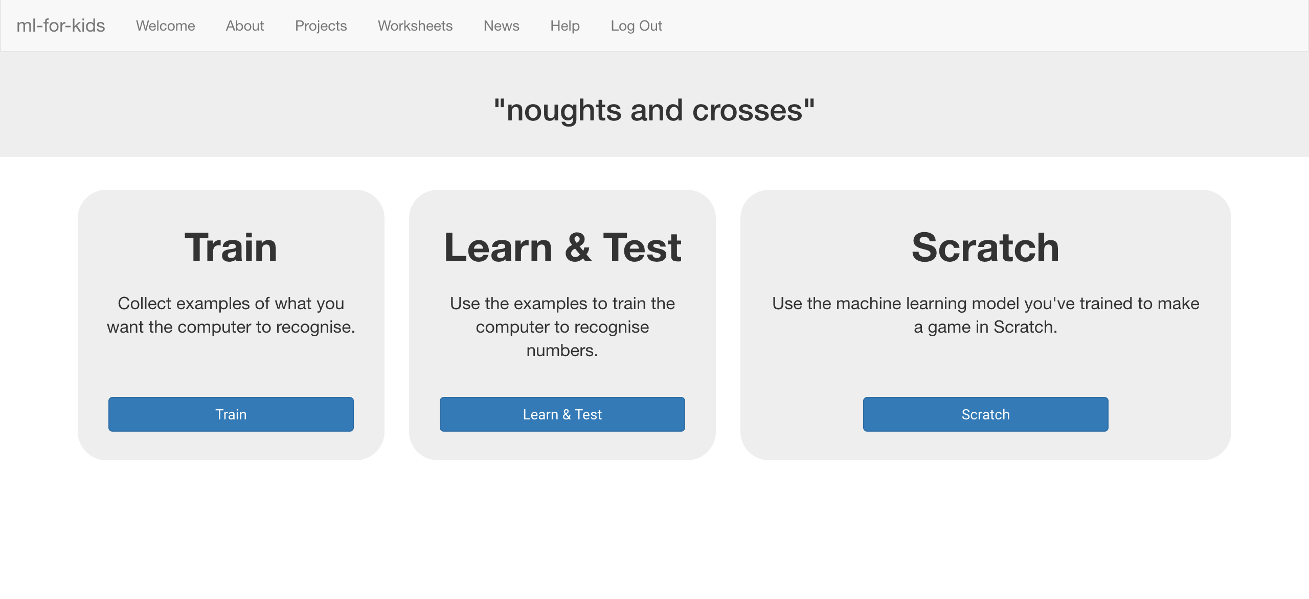
7. Click “**+ Add new label**” and create a label called “top left”  
   *Examples of making a move in the top-left box (in games that eventually ends in a win) will go in this bucket.*   
   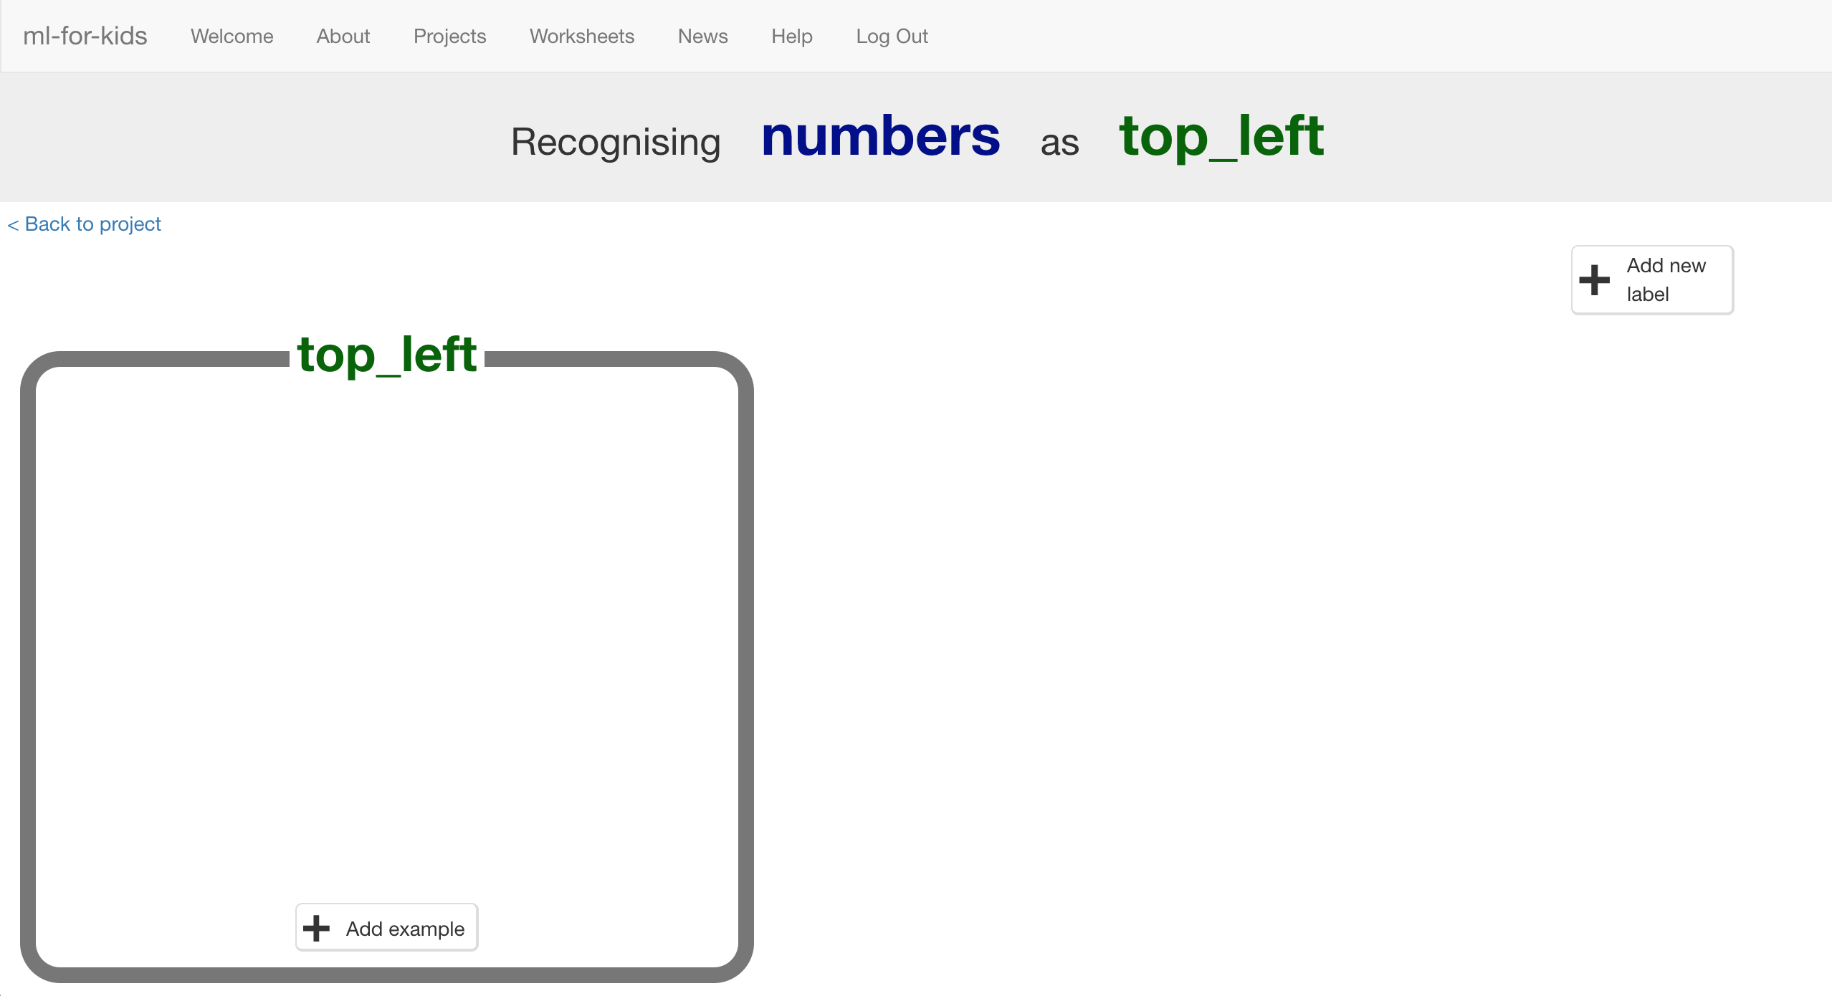

1. Click “+ Add new label” again and create labels for the other eight spaces on the board.  
   *“top middle”, “top right”, “middle left”, “middle middle”, “middle right”, “bottom left”, “bottom middle”, “bottom right”*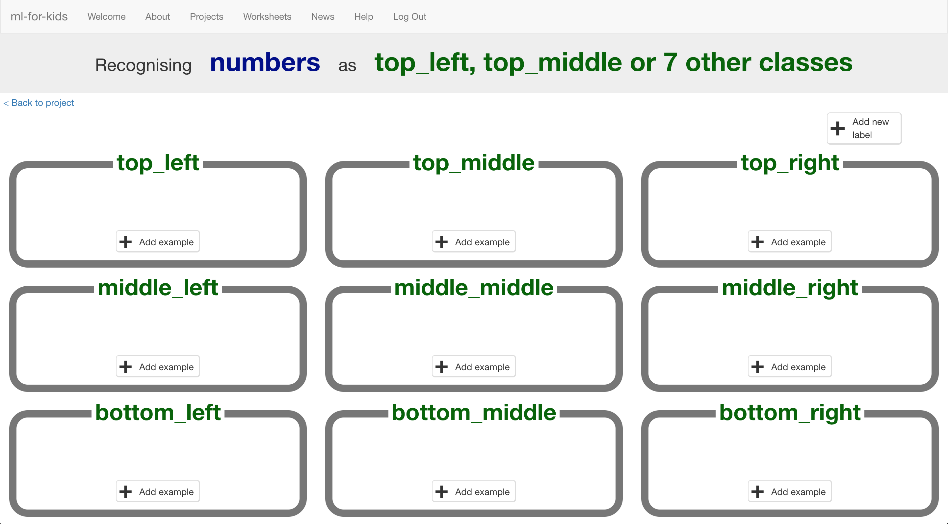
2. Click the “**< Back to project**” link then click **Scratch**
3. Click the **Open in Scratch** button  
   *It will warn you that you haven’t trained the computer yet – but that’s okay, as you’ll use Scratch to collect training examples.   
   Click the go “****straight into Scratch****” now button.   
   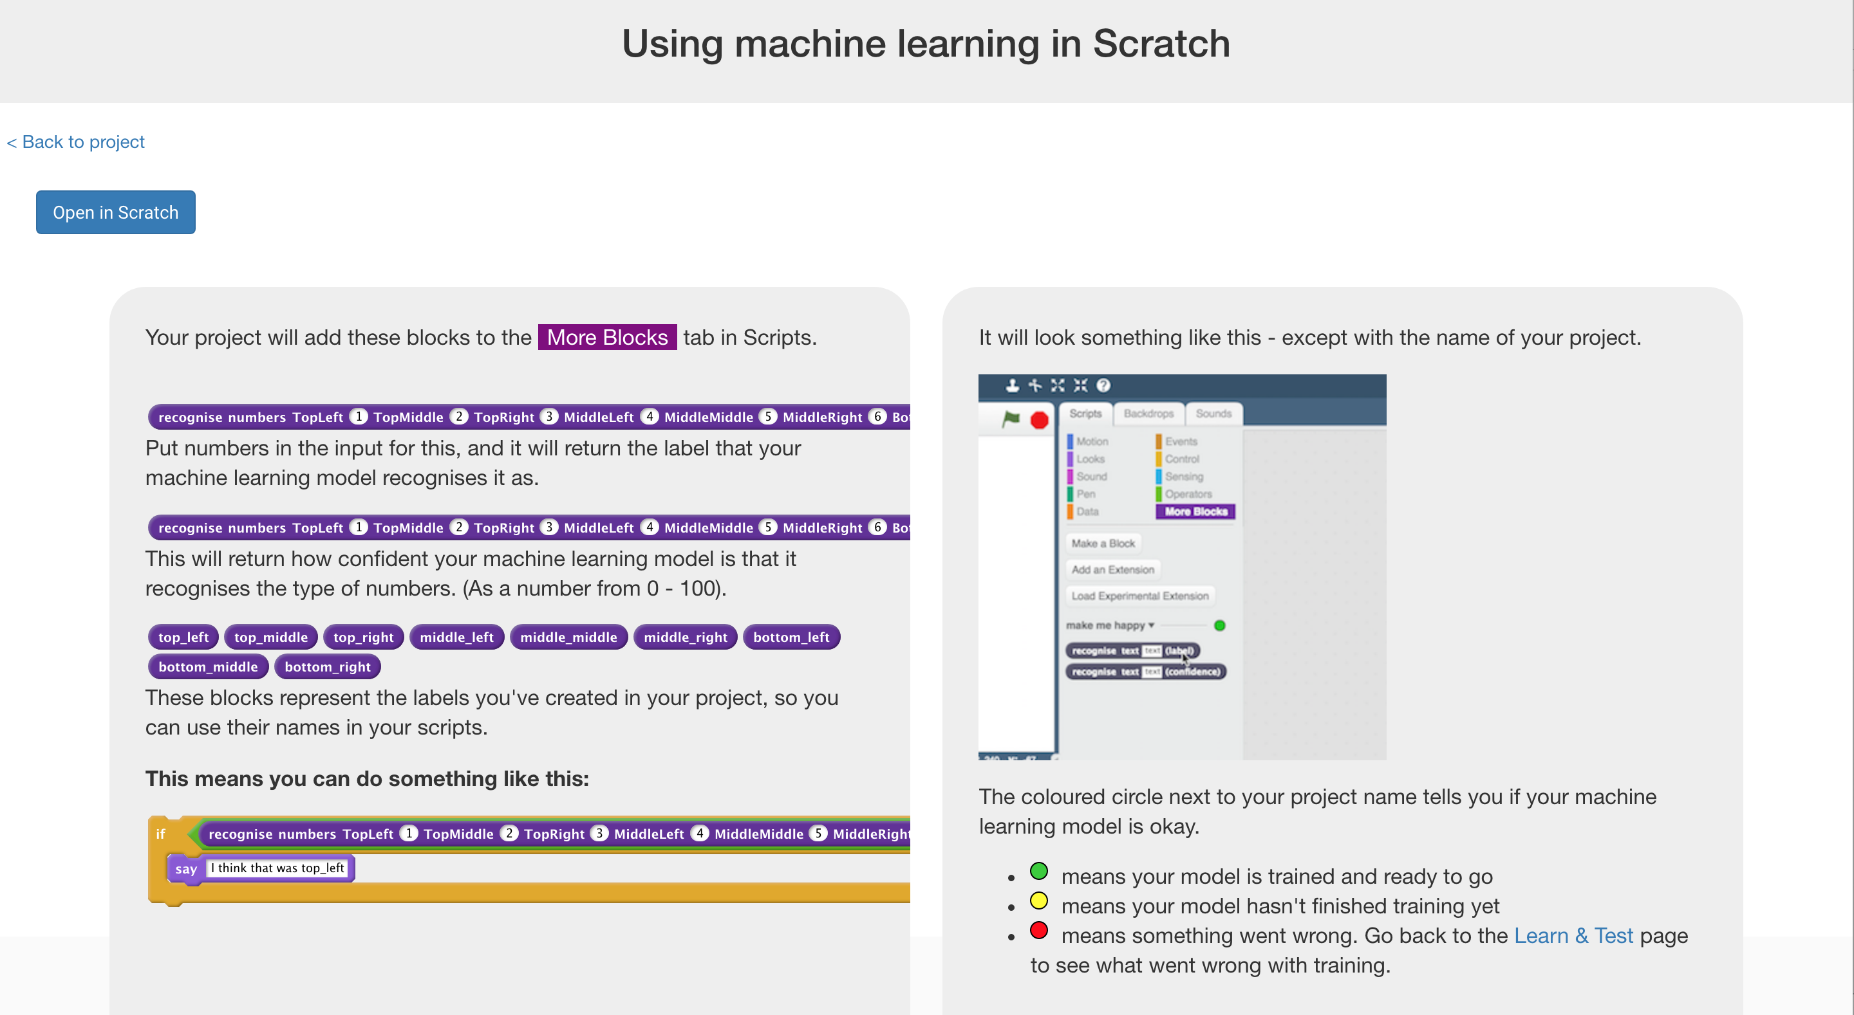*
4. You should see new blocks in the “**More blocks**” section from your “noughts and crosses” project.  
   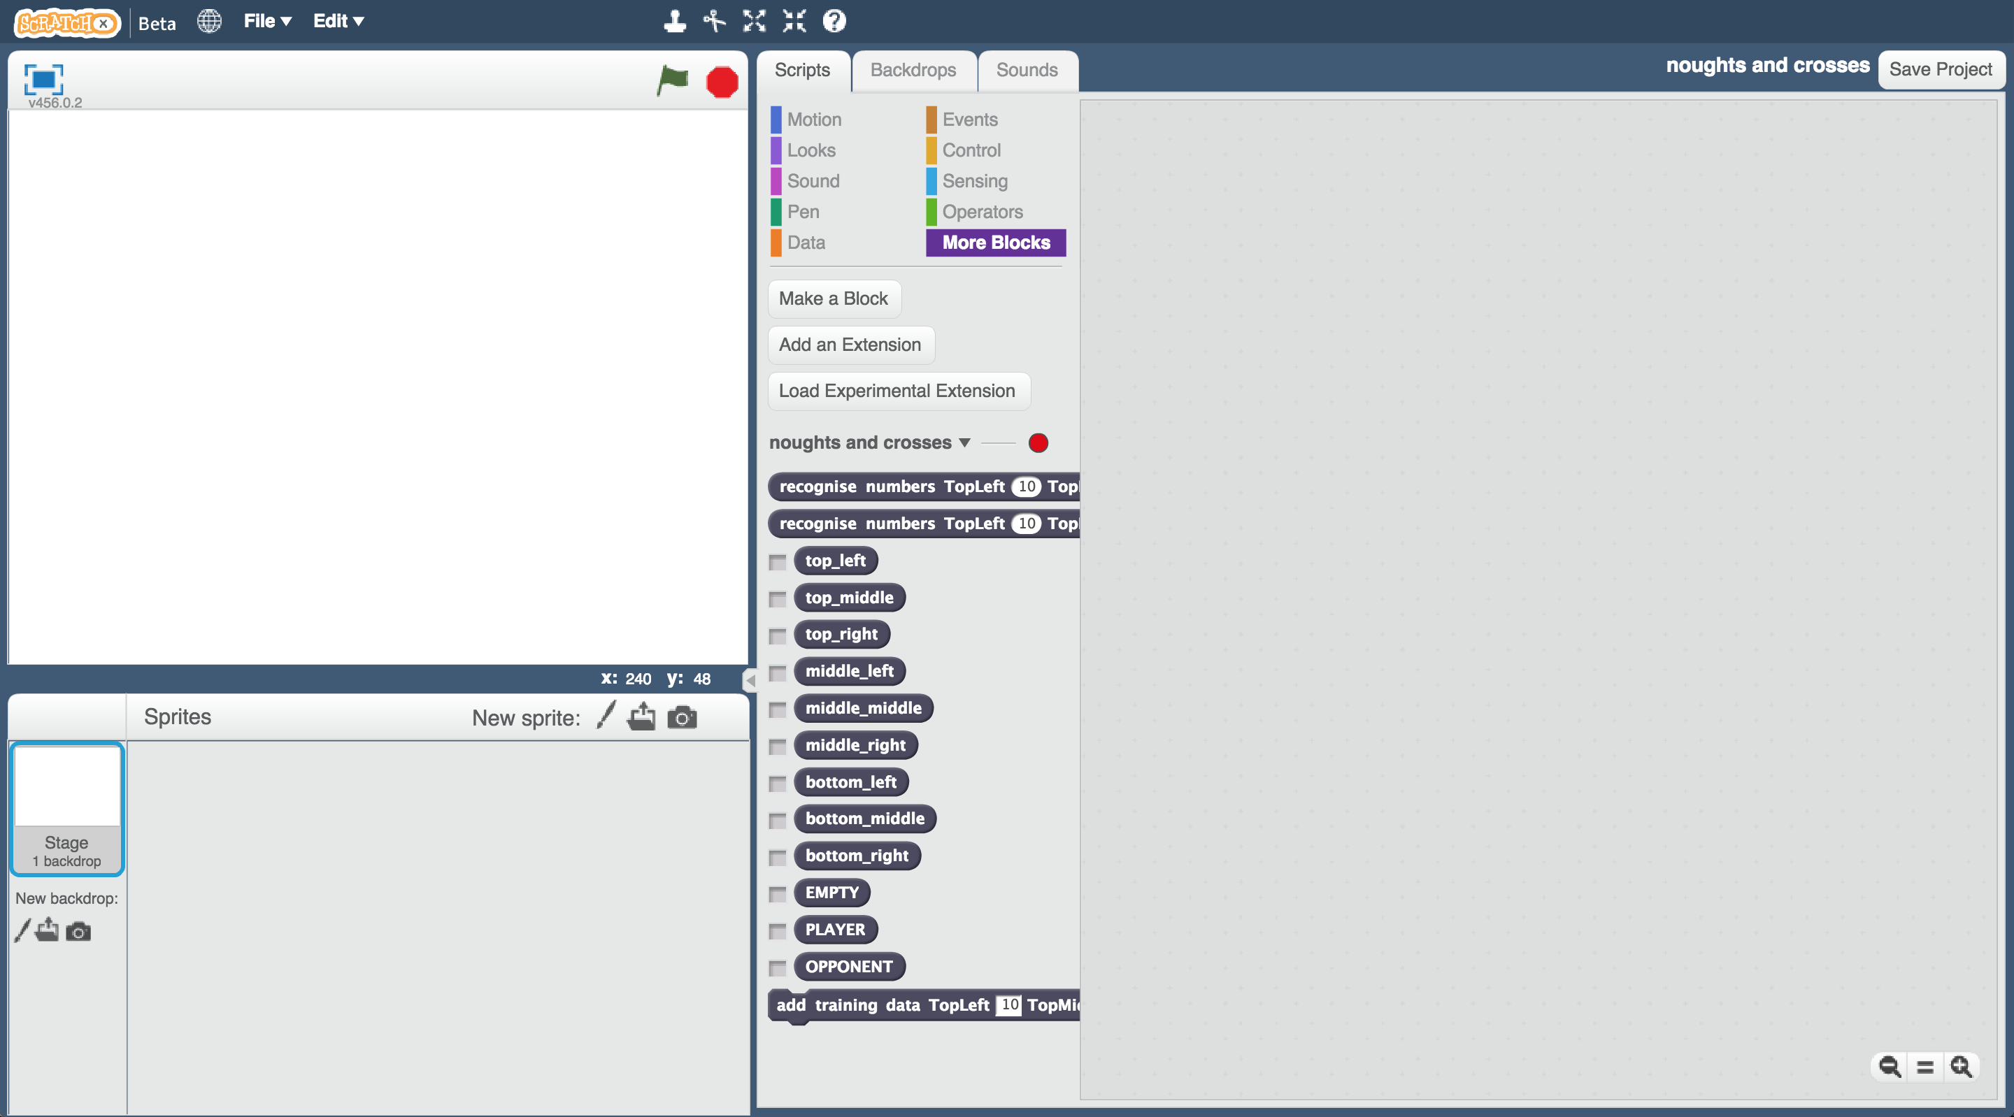
5. Open the Noughts and Crosses project template again.  
   *Click* ***Project templates*** *->* ***Noughts and Crosses***
6. Click on the “**Stage**”  
   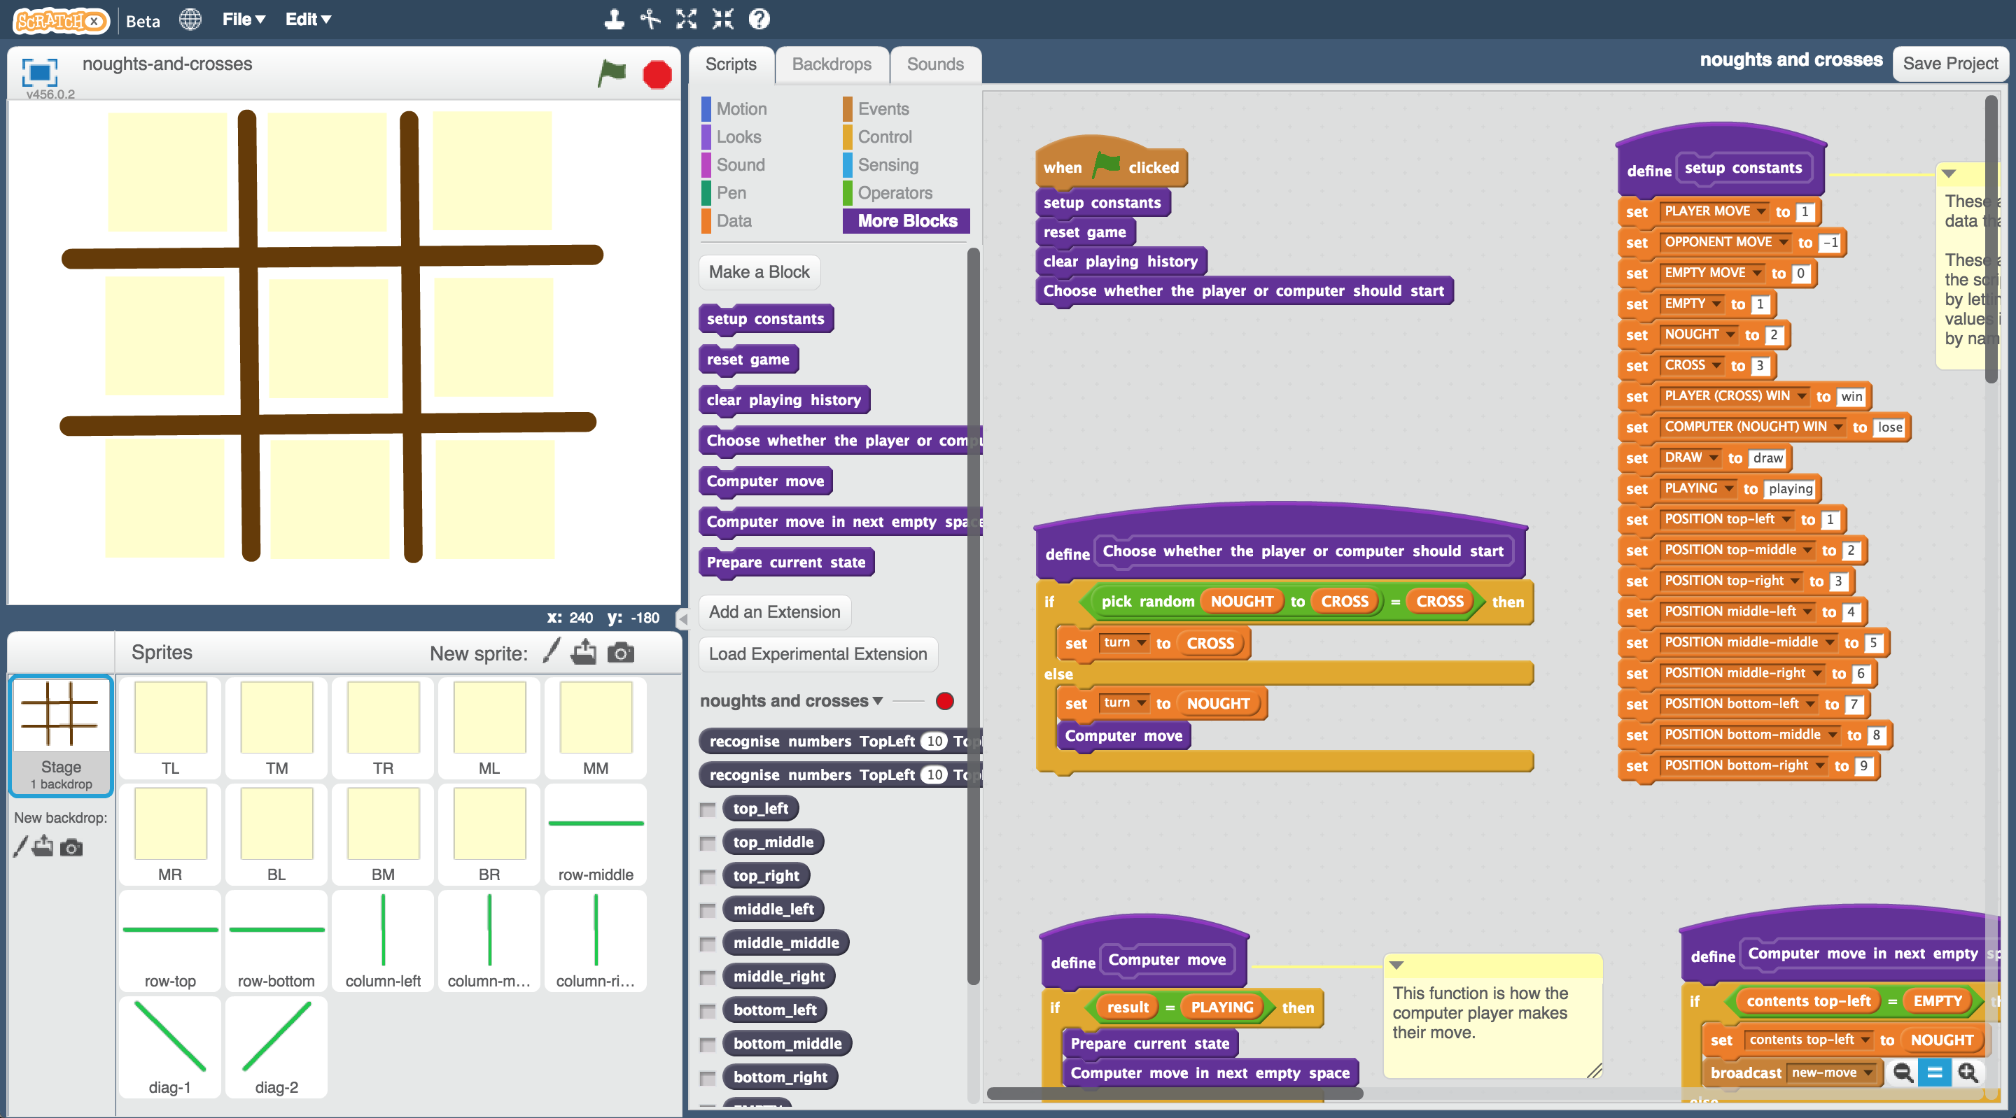
7. Modify the custom block “**setup constants**” to use the multiple choice values you created  
   *Drag the “EMPTY”, “PLAYER” and “OPPONENT” blocks from your “noughts and crosses” project into the top three spaces in the script like in the picture below.*  
   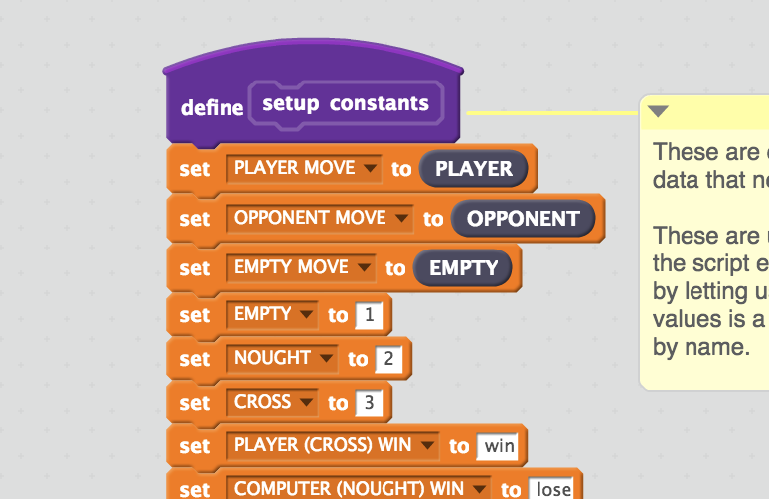
8. Click the **TL** (top-left space) sprite   
   *You’ll update the script to store when you click on this space for your move.*  
   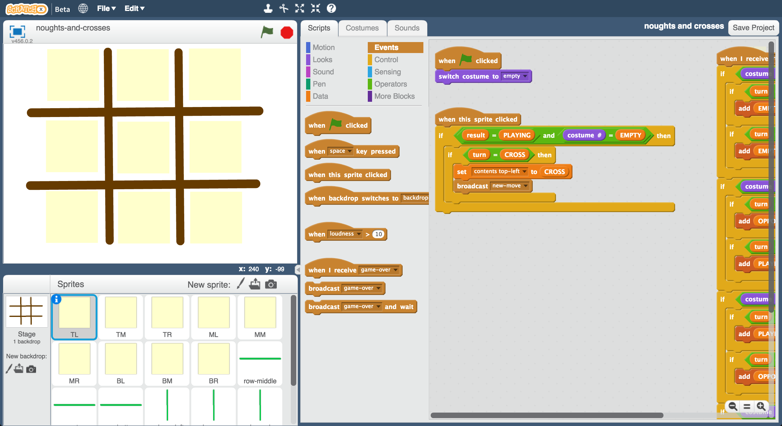
9. Modify the “**When this sprite clicked**”script to add **top_left** to the history of cross choices.  
   *You just need to add a single block to get the script to look like this:  
   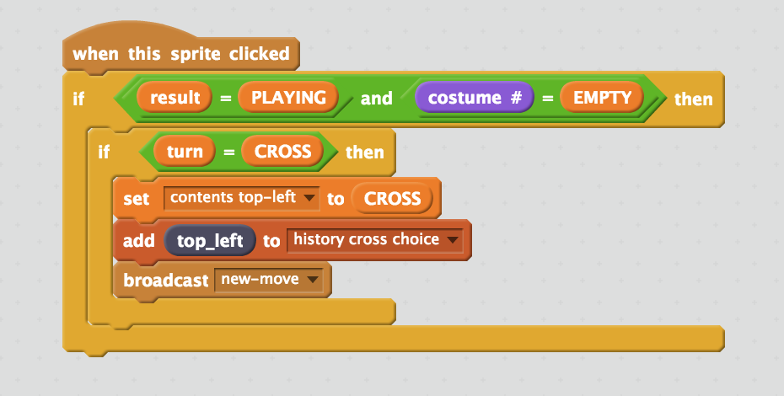*
10. Click the **TM** (top-middle) sprite.  
    Modify the script to add **top_middle** to the history of cross choices.  
    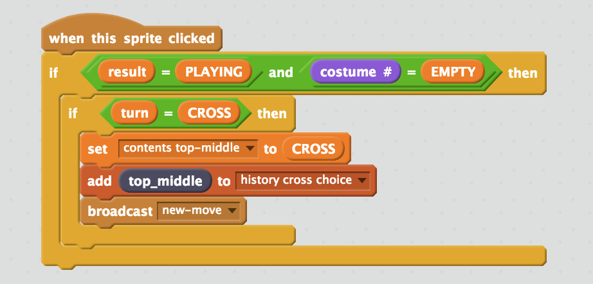

1. Repeat for the other seven board sprites  
   *Add top_right to the TR sprite. Add middle_left to the ML sprite.   
   Add middle_middle to the MM sprite. Add middle_right to the MR sprite. Add bottom_left to the BL sprite. Add bottom_middle to the BM sprite.   
   Add bottom_right to the BR sprite.*   
   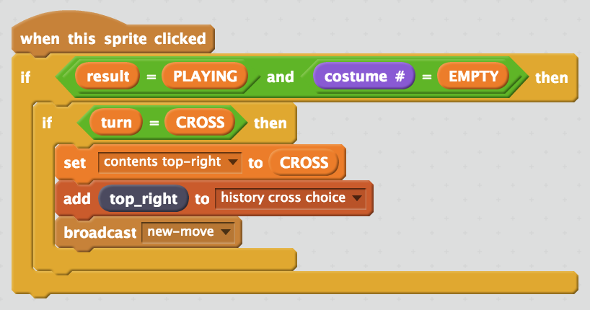 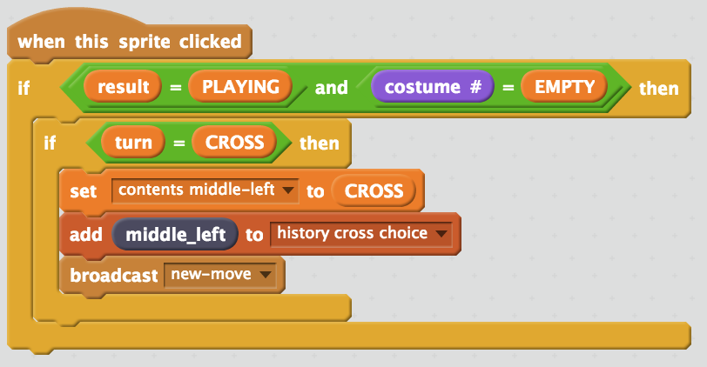 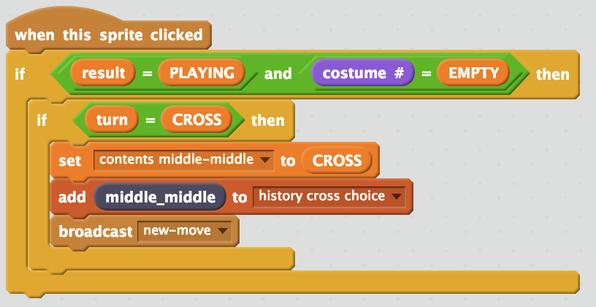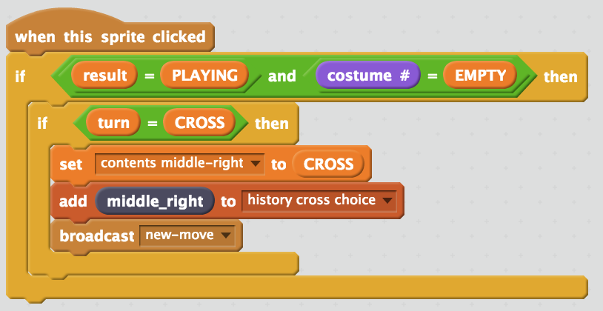 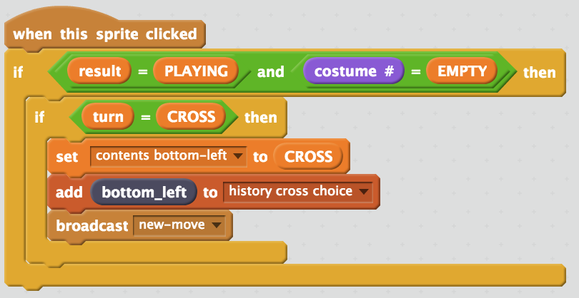 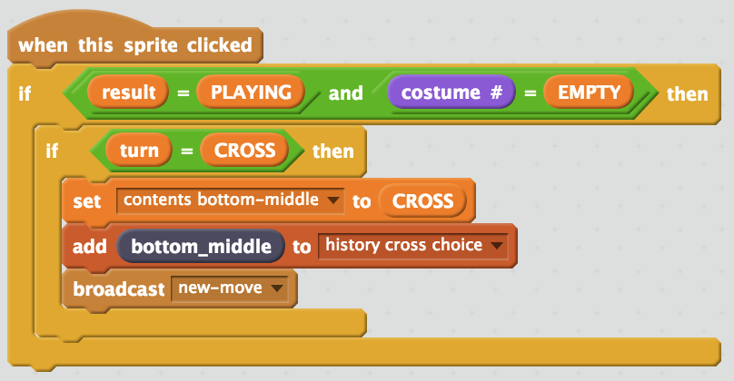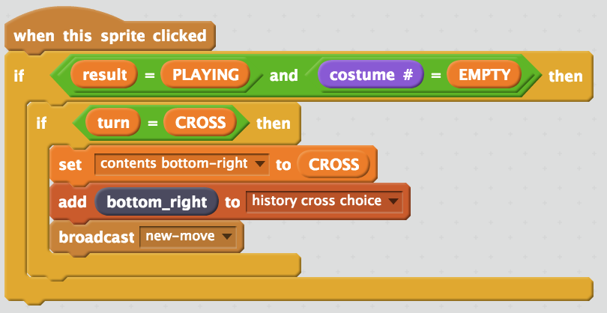
2. Click on the “**Stage**” again  
   *You’ll update the script to store when the computer makes its move*
3. Find the “**Computer move in next empty space**” script  
   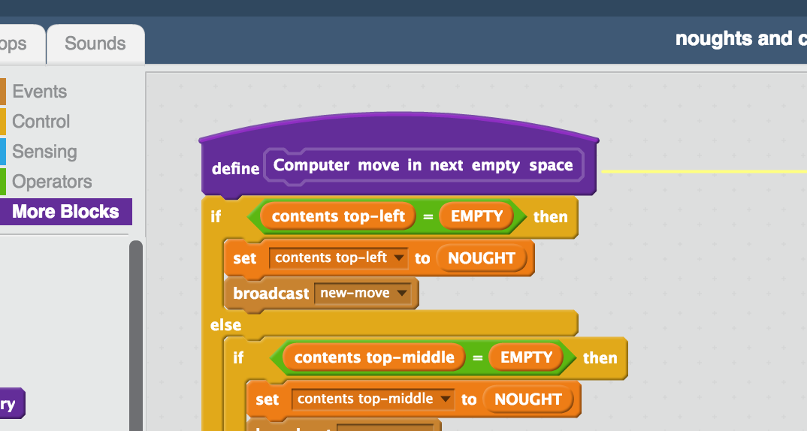
4. Modify the script to add each of the computer’s moves to the history of nought choices.  
   *You only need to add the* ***add CHOICE to ‘history nought choice’*** *blocks*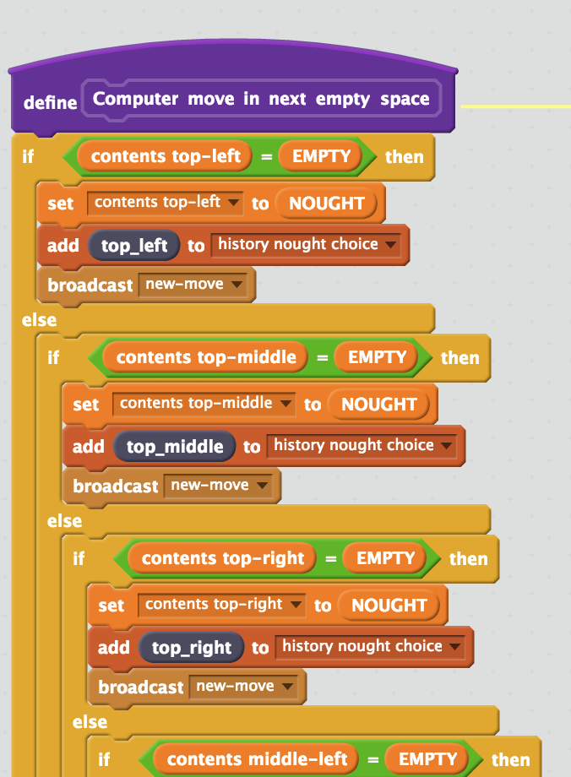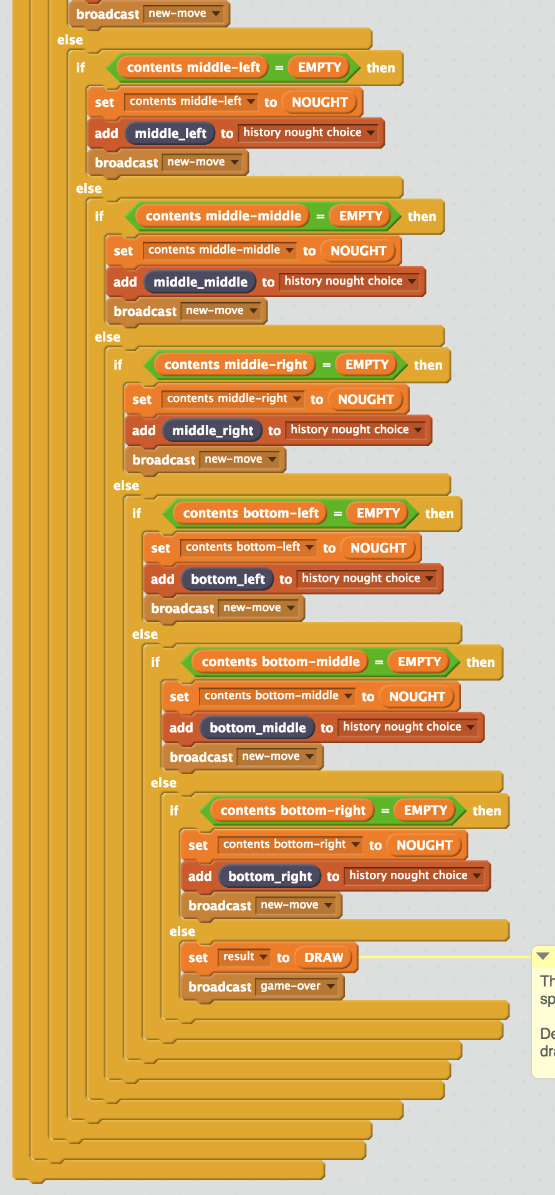
5. Create the following script (still in the **Stage**)  
   *This will add all of the history of moves made by the winning player to the training data that you will use to train the computer.   
   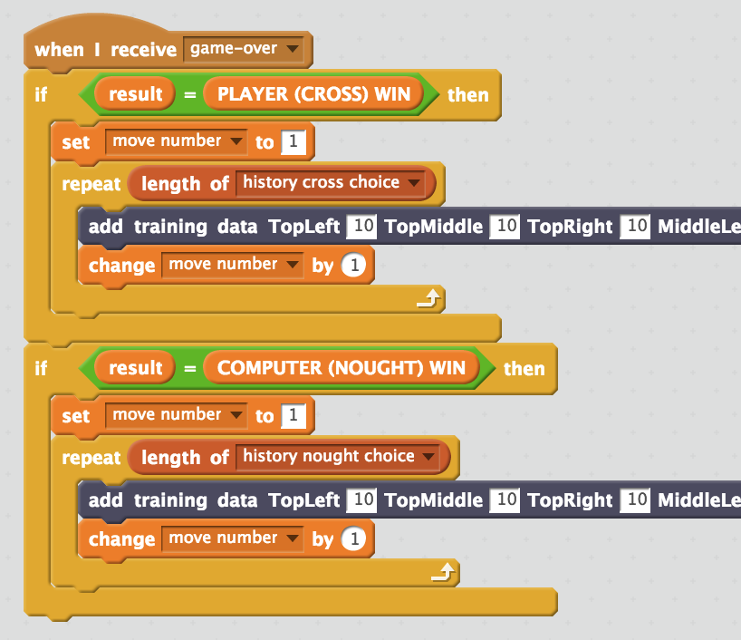*
6. Add the following items to the **first** “add training data” block  
   *If the game ends with the player (CROSS) winning, all the moves you want to add to the training data should be from the* ***cross*** *histories.  
   And you end with the choice of move that was made.  
   * 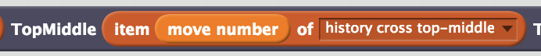 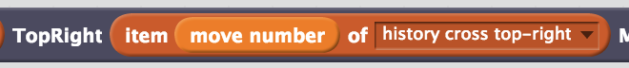 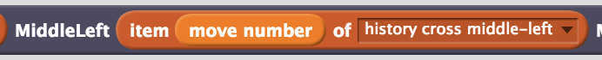      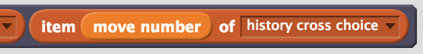
7. Add the following items to the **second** “add training data” block  
   *If the game ends with the computer (NOUGHT) winning, all the moves you want to add to the training data should be from the* ***nought*** *histories.  
   And you end with the choice of move that was made.  
   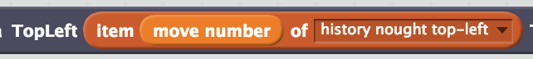* ** 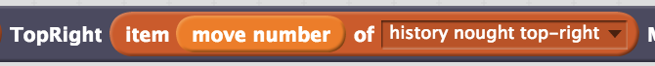       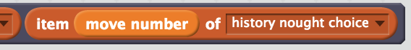
8. The final script should look like this  
   *Double-check that the top “add training data” row is all from “history nought” lists, and matches the board space. (e.g. TopLeft with top-left)  
   Double-check that the bottom “add training data” row is all from “history cross” lists, and matches the board space. (e.g. TopLeft with top-left)*  
   *Do this carefully – any mistakes will confuse the training.   
   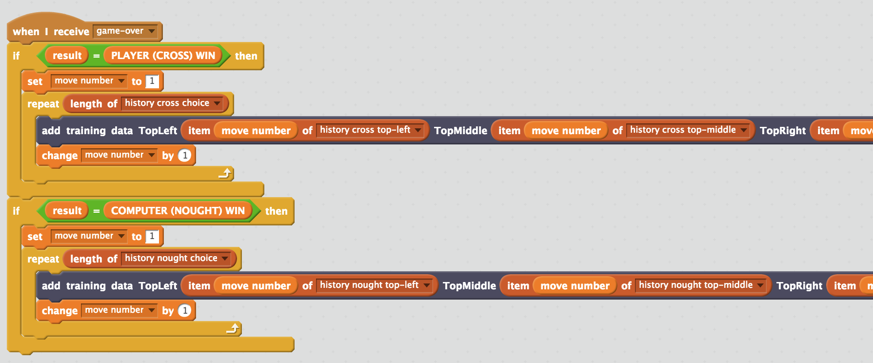*
9. Save your project  
   *Click* ***File*** *->* ***Save Project***
10. Play a few games  
    *Click on the* ***Green Flag*** *as you did before.   
    It is better to play in full-screen mode to avoid accidentally moving sprites.*

1. Go back to the training page  
   *Leaving the Scratch window open, go back to the training tool window.   
   Click the “****< Back to project****” link and then click “****Train****”*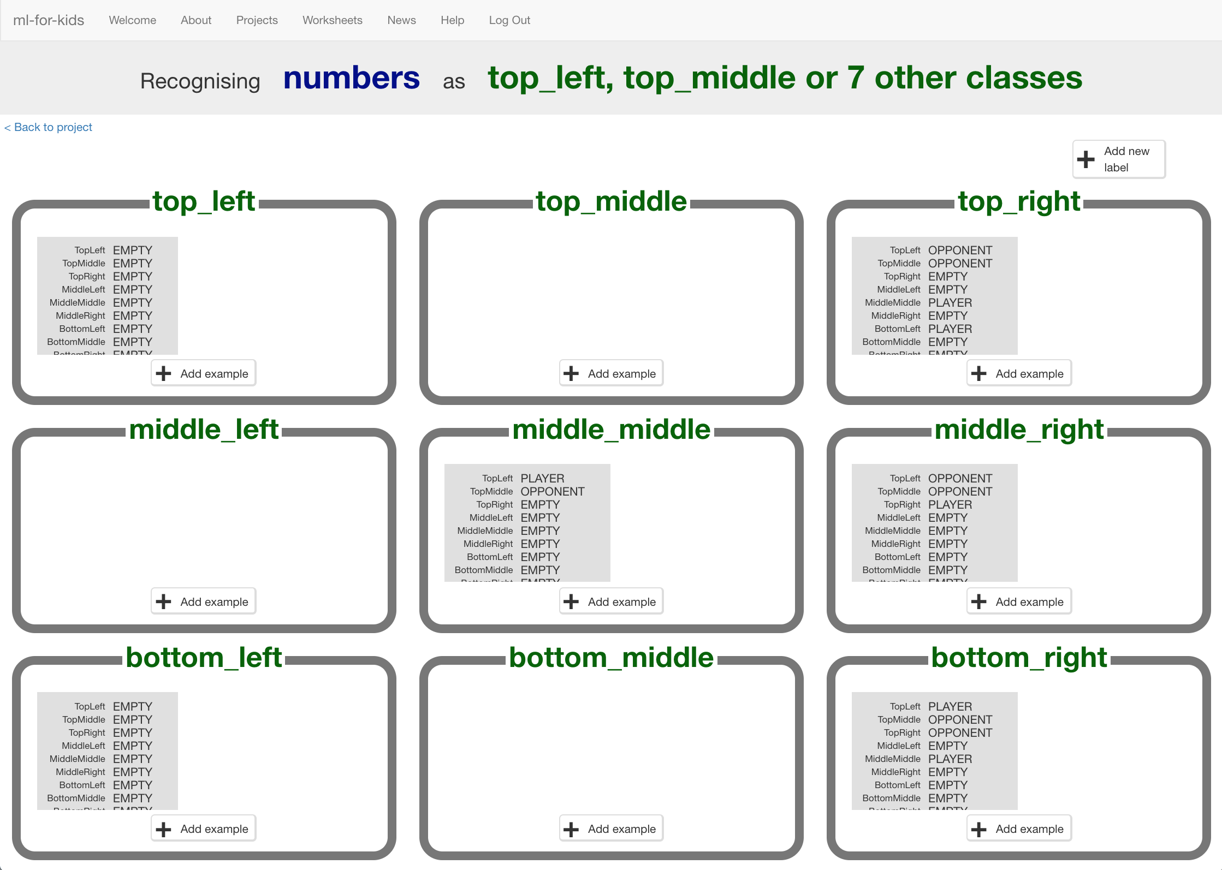
2. Look at your training so far  
   *Each item is the state of the board at the time you or the computer made a move (in a game that you or the computer won).   
   The bucket that the item is in is the move that you made.   
   If there are any empty buckets – like top_middle, middle_left and bottom_middle in the screenshot before – that means you haven’t made a move in that space in a game that you won yet.*
3. Click the “**< Back to project**” link. Click the “**Learn & Test**” button.
4. If there is a “**Train new machine learning model**” button you can go to step **47**. Otherwise, carry on to step 43.
5. You don’t have enough examples to train the computer yet  
   *For the computer to know when it is a good idea to choose any space on the board, you need at least 5 examples of where you chose that space and ended up winning.   
   This page shows you how many examples you have so far. Look to see which one(s) you need more examples for.*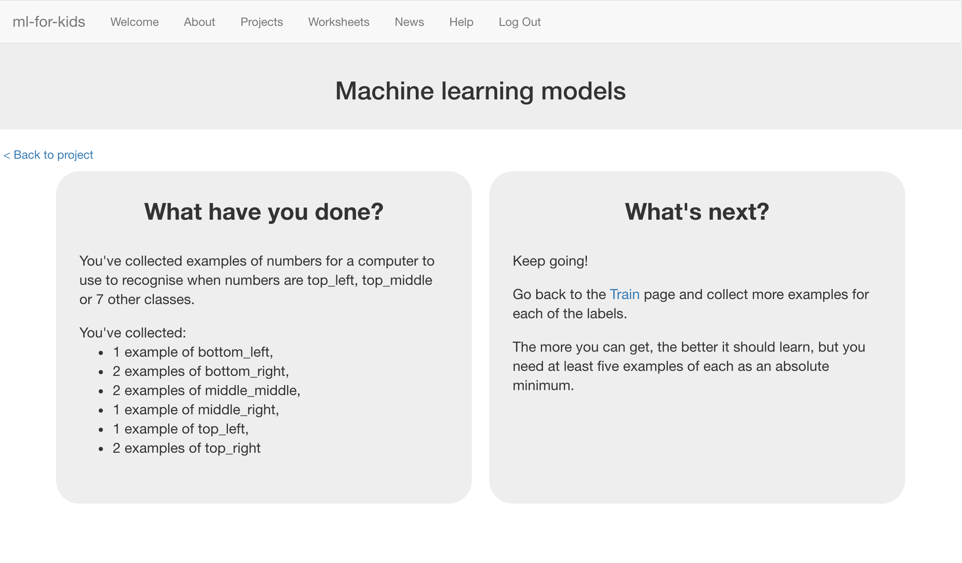
6. Leave the “**Learn & Test**” window open.   
   Go back to the **Scratch** window.
7. Play more games.   
   *Try starting from a different position each time to get a variety of examples.   
   Try starting from positions that you know you need more examples of.*
8. When you think you’ve got at least 5 examples of each space, go back to the “**Learn & Test**” window and **refresh** the page.   
   *If there is still no “Train new machine learning model” button, you need to go back to step 44 and try again.*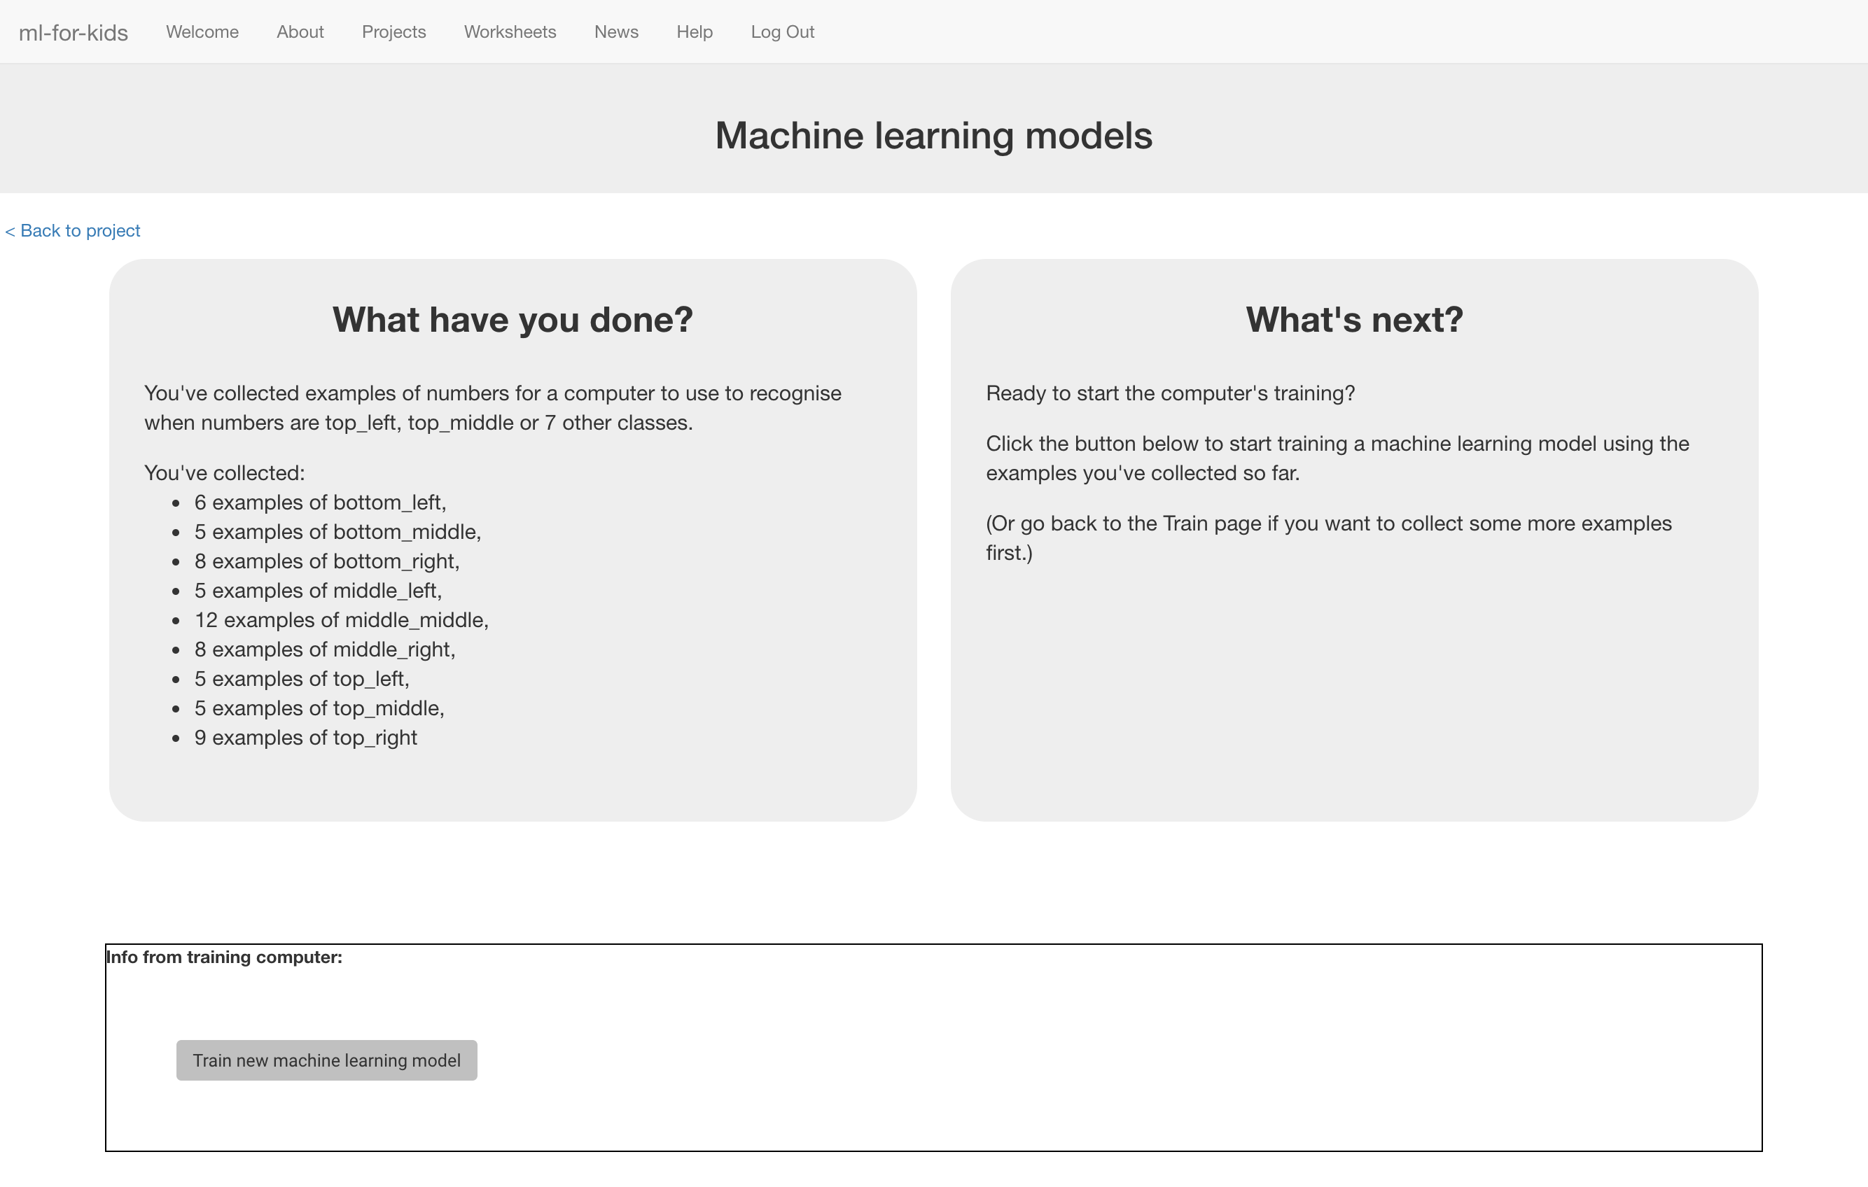
9. Click the “**Train new machine learning model**” button at the bottom of the page.

**What have you done so far?**

You’re teaching a computer to play noughts and crosses.

So far, you’ve updated a Scratch noughts and crosses game so that it can collect examples of how you play and add them to a set of examples. And you’ve used those examples to train a machine learning “model”.

The next step is to use that model to let the computer decide what move to make – instead of just going for the next empty space every time.

1. Close the Scratch window.  
   *Make sure you save your project first!*
2. In the training page, click the **“< Back to project**” link.   
   Then click the **Scratch** button.
3. Click the **Open in Scratch** button.  
   *The green circle means this time you have a machine learning model.*  
   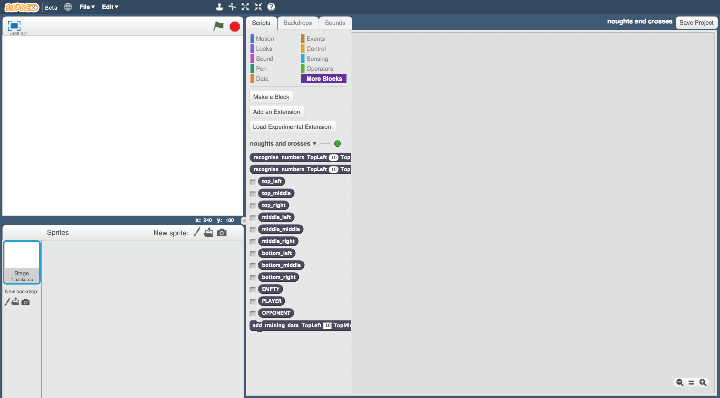
4. Open your saved project  
   *Click* ***File*** *->* ***Load Project***
5. Click on the **Stage** and find the **Computer move** script
6. Modify the **Computer move** script so that it looks like this  
   *Use the first “recognise numbers” block that* ***ends with “label”***  
   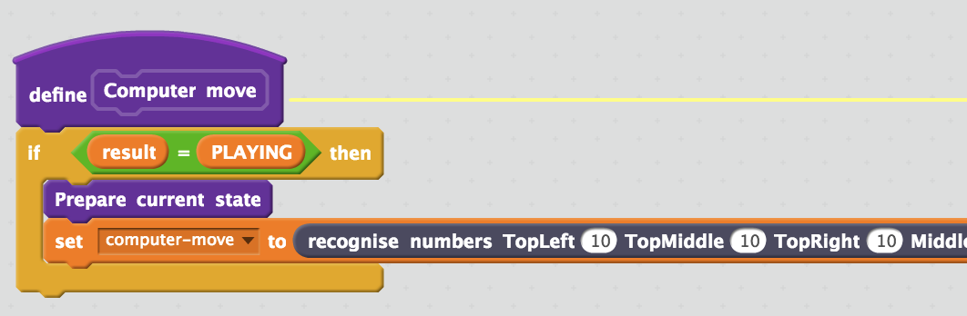
7. Add the current state for each space on the board to the “recognise numbers” block  
   *Make sure you use the “****current state”*** *orange blocks (not “contents”)*  
   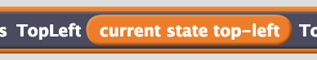  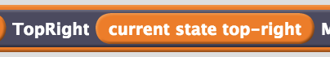 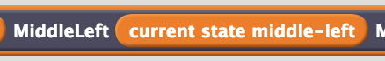 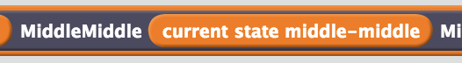 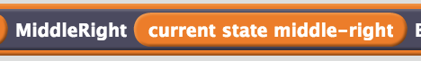 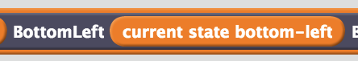 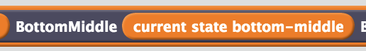 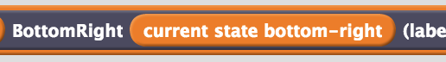
8. Modify the script to look like this  
   *This script will use the machine learning model to let the computer choose where to have a move… (as long as it chooses the top-left space).   
     
   While the computer is still learning, it may get things wrong. So there is also a check in the script to make sure that the computer has chosen an EMPTY space! If it’s chosen a space that already has a nought or cross in, it’ll just pick the next empty space.   
     
   It will also add the choice it’s made to the history, so it can be used in training data if it ends up winning.*  
   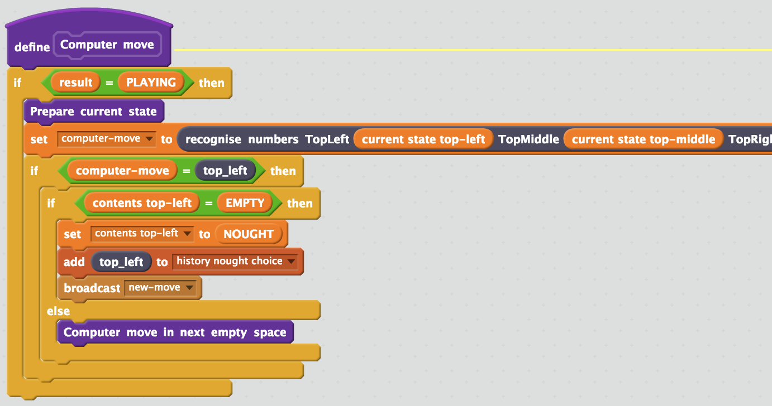
9. Update the **Computer move** script to handle the other choices the machine learning model could make. This is all one long script.   
   *Tip! Duplicate the “if computer-move” block by right-clicking on it to save time.  
   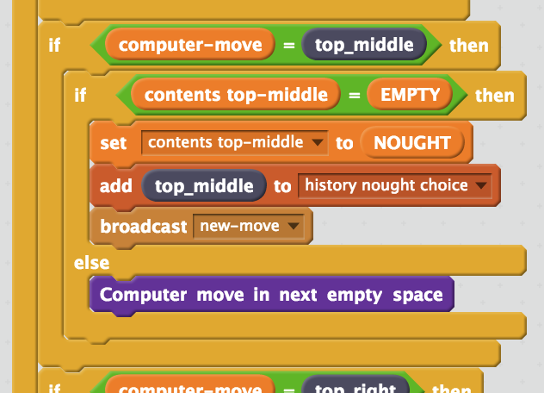* *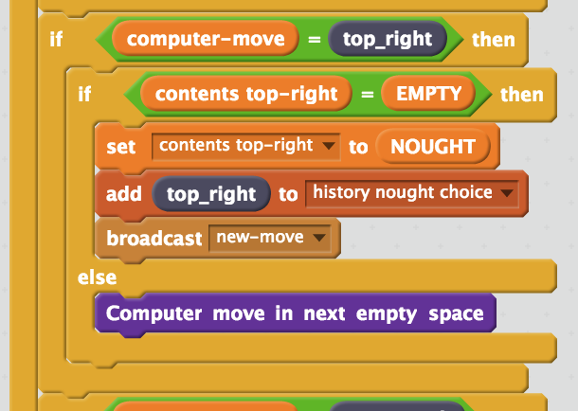  
   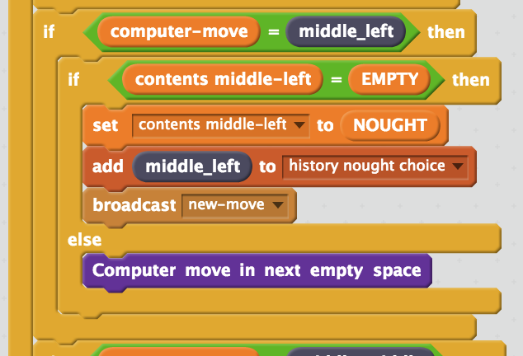* 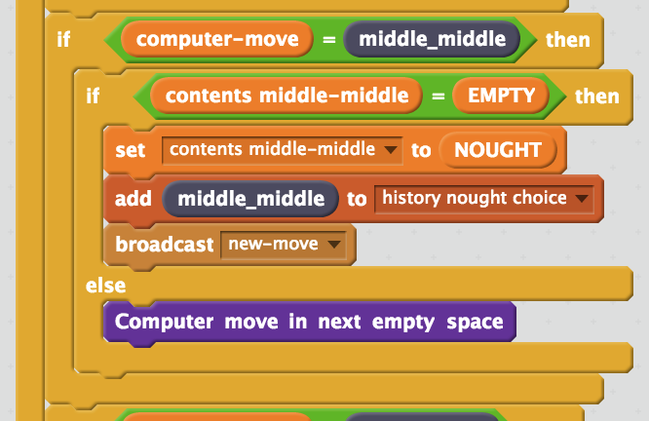 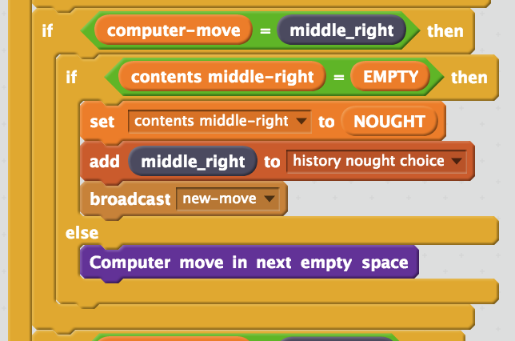 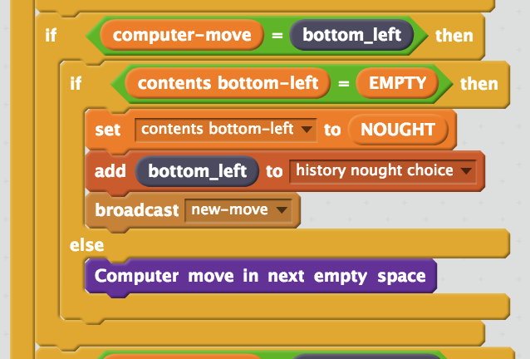 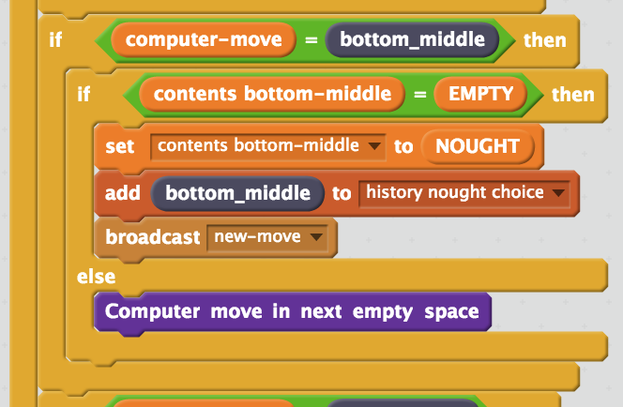 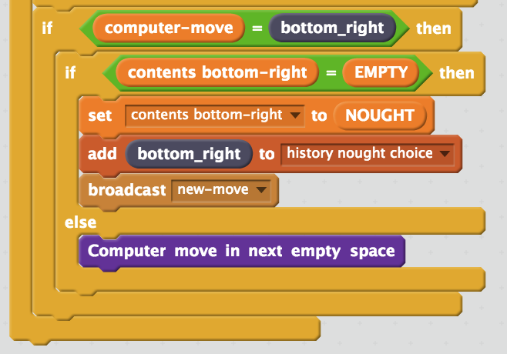
10. The whole script should end up looking like this.   
    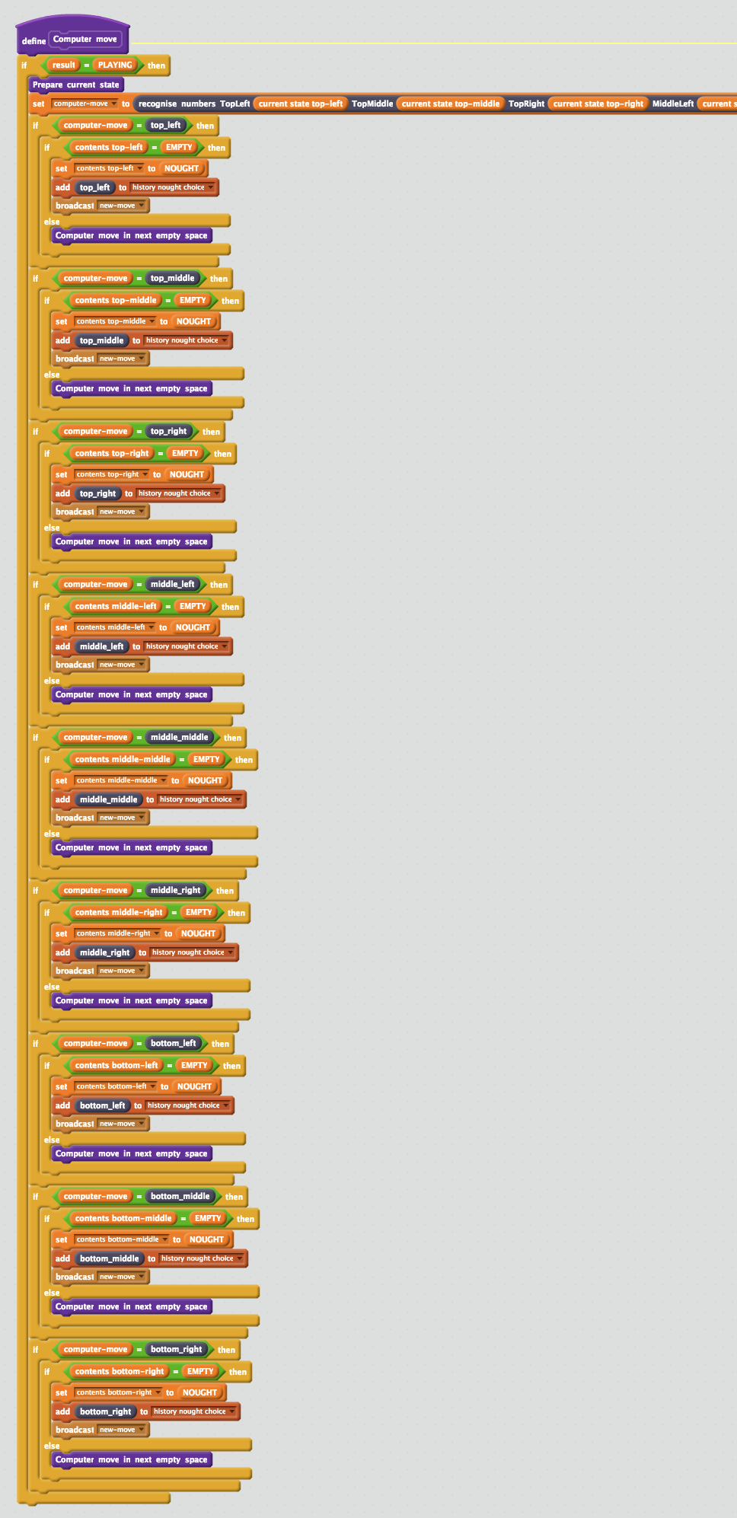
11. Save your project  
    *Click* ***File*** *->* ***Save Project***
12. Play against the computer by clicking on the **Green Flag**  
    *Use full-screen to avoid moving sprites accidentally.  
    Avoid playing the same game over and over again. Choose different spaces to give the computer a variety of examples of how to play.*
13. When it starts to feel like you’re playing the same games over and over again, go back to the Learn & Test screen, and use the new examples you’ve collected   
    *Click the “****Train a new machine learning model****” button again*  
    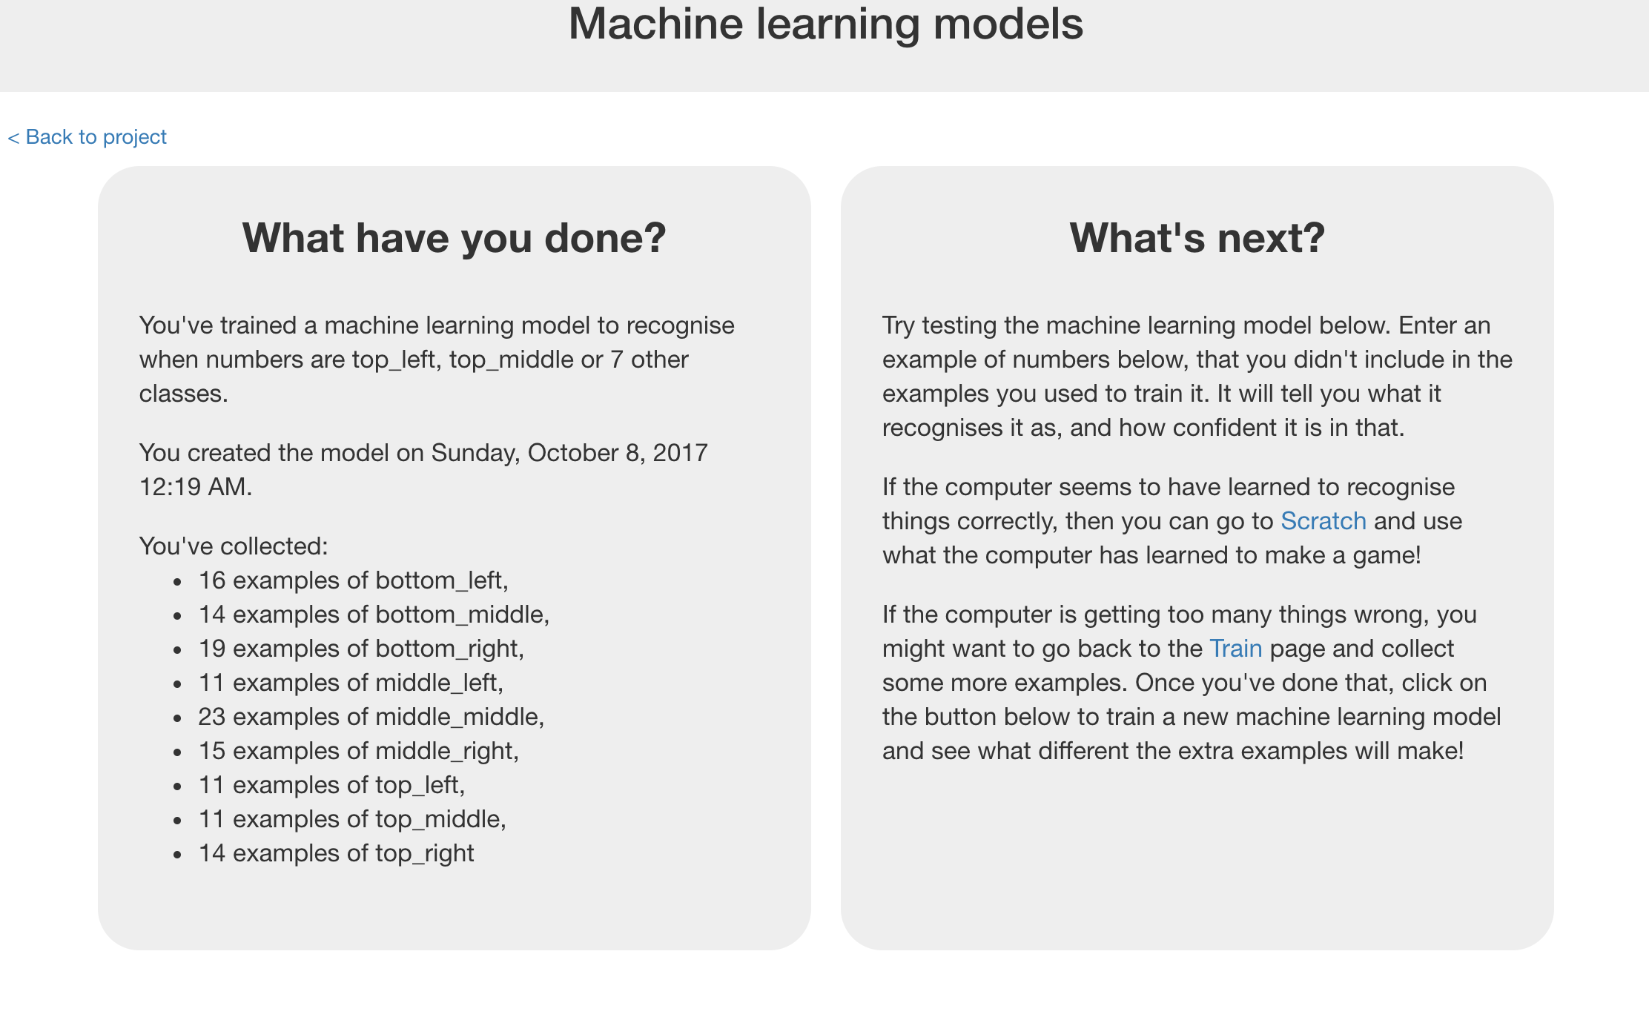
14. Go back to step 59 – and repeat  
    *Play against the computer, and try to vary your playing as much as possible.   
    Once you’re struggling to keep coming up with new games, click the Train new machine learning model button again.   
    Try to repeat this process a few times until your machine learning model starts getting good!*

**Tips**

**Don’t be kind!**

You might be tempted to go easy on the computer when you’re playing against it, particularly when it’s just starting to learn and is playing very badly.

For example, you might have two crosses-in-a-row next to a blank space and could win. But instead, you might feel sorry for it doing badly and put a cross somewhere else instead to give it a chance.

Don’t.

It is learning from the way that you play. If you don’t complete a three-in-a-row when you can, you will be teaching it that it should do that.

If you want it to get better quickly, **play as well as you can**.

**Mix things up with your examples**

Try to come up with lots of different types of examples.

For example, start from a different position on the board on every turn.

**What have you done?**

You’ve trained a computer to play noughts and crosses.

You didn’t have to describe the rules to the computer.

You didn’t tell it that it should try to get three noughts in a row.

You didn’t describe the difference between rows, columns or diagonals.

(The rules are in the Scratch game, but that doesn’t count – that wasn’t used in the machine learning model).

Instead, you showed it how you play, by collecting examples of decisions that you made when you win.

When it makes decisions that leads to it winning, this is added to its training data, so it can be even more confident in that approach in future.

This is called “reinforcement learning” because when it does something good you are “reinforcing” this by rewarding it.

**Did you know?**

People have been learning about machine learning by training a computer to play noughts and crosses for decades!

One famous example was **Donald Michie** – a British artificial intelligence researcher. During World War II, Michie worked at Bletchley Park as a code breaker.

In 1960, he developed “**MENACE**” – the Machine Educable Noughts And Crosses Engine. This was one of the first programs able to learn how to play noughts and crosses perfectly.

As he didn’t have a computer he could use, Michie built MENACE using 304 matchboxes and coloured glass beads.

Each matchbox represented a possible state of the board – like the examples that you’ve been collecting in your training data.

He put beads in the matchboxes to show how often a choice led to a win – the number of beads in the matchbox was like the number of times an example shows up in one of the buckets you created for your training data.

